  - CAMS2_61 – Global and European emission inventories

Contribution to documentation of products provided by CAMS2_61

Issued by: H. Denier van der Gon (TNO), M. Gauss (MET Norway), C. Granier (CNRS)
Date: ??/12/2024
Ref: CAMS261_2021SC1_D6.1.2-2024_202412_Docu_v1.docx
CAMS261_2021SC1_D6.1.2-2024_202412_Docu_v1

This document has been produced in the context of the Copernicus Atmosphere Monitoring Service (CAMS).
The activities leading to these results have been contracted by the European Centre for Medium-Range Weather Forecasts, operator of CAMS on behalf on the European Union (Contribution Agreement signed on 22/07/2021). All information in this document is provided “as is” and no guarantee of warranty is given that the information is fit for any particular purpose.
The users thereof use the information at their sole risk and liability. For the avoidance of all doubt, the European Commission and the European Centre for Medium-Range Weather Forecasts have no liability in respect of this document, which is merely representing the author’s view.
  - Contributors

Barcelona Supercomputing Center, Spain
Marc Guevara

Chalmers University of Technology, Sweden
Santiago Arellano

Charles University, Czechia
Katerina Sindelarova, Marina Liaskoni, Jana Markova, Alvaro Prieto Perez

Finnish Meteorological Institute, Finland
Jukka-Pekka Jalkanen

GEOMAR, Kiel, Germany
Birgit Quack

Laboratoire d'Aérologie, France
Claire Granier
Cathy Liousse
Antonin Soulie

Norwegian Meteorological Institute, Norway
Anna Benedictow
David Simpson
Michael Gauss

Observatoire Midi-Pyrénées, France
Sabine Darras

TNO, Netherlands
Stijn Dellaert
Hugo Denier van der Gon
Jeroen Kuenen

University of Oslo, Norway
Kirstin Krueger

Table of Contents
1 Introduction 12
1.1 Contact for users 12
1.2 References 12
2 The CAMS regional anthropogenic emissions: CAMS-REG-AP and CAMS-REG-GHG 13
2.1 Methodology 13
2.1.1 Data collection 13
2.1.2 Specifics for this version 14
2.1.3 Spatial allocation of emissions 15
2.1.4 Additionally added emissions 16
2.1.5 Emission profiles 17
2.2 Emissions data 17
2.3 Versions of the dataset 21
2.4 Associated datasets 22
2.4.1 Alternative inventory for specific sources 22
2.4.2 Recent year emissions 22
2.5 References 23
3 The CAMS global anthropogenic emissions: CAMS-GLOB-ANT 24
3.1 Methodology 24
3.2 Emissions provided by the CAMS-GLOB-ANT_6.1 inventory 30
3.3 Versions of the dataset 31
3.4 References 31
4 The CAMS ship emissions: CAMS-GLOB-SHIP 32
4.1 Methodology 32
4.2 Emissions data 33
4.3 Versions of the dataset 34
4.4 References 34
5 The CAMS aircraft emissions: CAMS-GLOB-AIR 35
5.1 Methodology 35
5.2 Emissions data 35
5.3 Versions of the dataset 36
5.4 References 36
6 The CAMS anthropogenic temporal profiles: CAMS-TEMPO 37
6.1 Methodology 37
6.1.1 Energy industry 40
6.1.2 Residential/Commercial combustion 41
6.1.3 Manufacturing industry 42
6.1.4 Refineries 43
6.1.5 Road transport 43
6.1.6 Aviation 44
6.1.7 Shipping 45
6.1.8 Other mobile sources 45
6.1.9 Agriculture 45
6.1.10 Processing of original CAMS-REG-TEMPO 47
6.2 Emissions data 47
6.3 Versions of the dataset 48
6.4 References 49
7 The CAMS emissions of biogenic VOCs: CAMS-GLOB-BIO 52
7.1 Methodology 52
7.1.1 Emission model and driving meteorology 52
7.1.2 Emission potentials 52
7.1.3 Vegetation description 53
7.2 Emissions data 54
7.3 Versions of the dataset 56
7.4 References 58
8 The CAMS termite emissions: CAMS-GLOB-TERM 59
8.1 Methodology 59
8.2 Emissions data 60
8.3 Versions of the dataset 61
8.4 References 61
9 The CAMS soil emissions: CAMS-GLOB-SOIL 63
9.1 Summary 63
9.2 Methodology 63
9.2.1 Landcover 64
9.2.2 Calculation of F_{biome} 65
9.2.3 Calculation of F_{Nfert} 65
9.2.4 Calculation of F_{Ndep} 65
9.2.5 Calculation of F_{pulse} 66
9.2.6 Calculation of CRF 67
9.2.7 Tropical rainforests 67
9.2.8 Temperatures 67
9.3 Results 67
9.4 Evaluation and follow-up 68
9.5 Versions of the dataset 71
9.6 Acknowledgements 72
9.7 References 72
10 The CAMS oceanic emissions: CAMS-GLOB-OCE 75
10.1 Methodology 75
10.1.1 DMS emissions 75
10.1.2 Volatile short-lived halogenated substances 77
10.1.3 OCS 79
10.2 Emissions data 80
10.2.1 DMS 80
10.2.2 Volatile short-lived halogenated substances 80
10.2.3 OCS 80
10.3 Versions of the dataset 81
10.4 References 81
11 The CAMS volcanic emissions: CAMS-GLOB-VOLC 83
11.1 Introduction 83
11.2 Methodology 84
11.3 Versions of the dataset 89
11.4 References 89

Introduction

Accurate quantification of surface emissions from anthropogenic and natural sources is crucial input to atmospheric models performing forecasts and analyses of air quality and atmospheric composition. As part of the European Copernicus Atmosphere Service (CAMS), various emission datasets have been developed. Global and regional European anthropogenic emissions for several sectors for a large number of atmospheric compounds have been developed. In addition, detailed emissions from ships based on ship identification systems have been developed. Different datasets providing natural emissions are being processed, such as the emissions of biogenic volatile organic compounds from vegetation, nitrogen compounds emissions from soils, emissions from the oceans and emissions from volcanoes. Methodologies for evaluating the emissions and their consistency at different scales are being generated. Temporal profiles to break down the annual total emissions to monthly, daily or hourly emissions are also being developed.

All the emissions developed in CAMS are or will be available from the CAMS Atmosphere Data Store (ADS), at: https://ads.atmosphere.copernicus.eu/.

This document details the status of the development of each emission dataset. Most datasets have been published in peer-reviewed journals and the respective articles will be referenced in each corresponding chapter. In cases where peer-reviewed publication has not yet occurred, we recommend that users of the CAMS emission datasets use the information provided in the relevant sections of this documentation along with the indicated references therein. More and updated information will be available from the CAMS ADS under Terms & Conditions.

This document updates and replaces the previous version published by Denier van der Gon et al. (2023), which was an update of Granier et al. (2019).

Contact for users

For further information or questions about the CAMS emissions products, see
https://atmosphere.copernicus.eu/anthropogenic-and-natural-emissions

References

Denier van der Gon, H., Gauss, M., Granier, C., Arellano, S., Benedictow, A., Darras, S., Dellaert, S., Guevara, M., Jalkanen, J.-P., Krueger, K., Kuenen, J., Liaskoni, M., Liousse, C., Markova, J., Perez, A. P., Quack, B., Simpson, D., Sindelarova, K., and Soulie, A.: Documentation of CAMS emission inventory products, Copernicus Atmosphere Monitoring Service, doi:10.24380/q2si-ti6i, URL https://atmosphere.copernicus.eu/node/1054, 2023.
Granier, C., S. Darras, H. Denier van der Gon, J. Doubalova, N. Elguindi, B. Galle, M. Gauss, M. Guevara, J.-P. Jalkanen, J. Kuenen, C. Liousse, B. Quack, D. Simpson, K. Sindelarova, The Copernicus Atmosphere Monitoring Service global and regional emissions (April 2019 version), Copernicus Atmosphere Monitoring Service (CAMS) report, 2019, doi:10.24380/d0bn-kx16.

The CAMS regional anthropogenic emissions: CAMS-REG-AP and CAMS-REG-GHG

Authors: Jeroen Kuenen, Stijn Dellaert, Hugo Denier van der Gon

Methodology

The CAMS regional anthropogenic emission inventory (Kuenen et al., 2022) covers emissions for UNECE-Europe for the main air pollutants and greenhouse gases. The method starts from the reported emissions by European countries to UNFCCC (for greenhouse gases) and to EMEP/CEIP (for air pollutants). The data are collected at the highest level of detail available and, using additional auxiliary data, have been compiled into around 250 different combinations of sectors and fuels. Because of the different level of detail in reporting between air pollutants and greenhouse gases, aggregation and/or disaggregation was performed to harmonise the sectors between all pollutants and countries.
This report describes the general approach from the CAMS-REG inventory and provides additional details for the latest version of the dataset (CAMS-REG-v6.1).

Data collection

The reported data have been checked for gaps, errors and inconsistencies and form the basis for the CAMS regional inventory for 2019 and 2020 (CAMS-REG_v6.1). Where needed, reported data from selected countries were replaced or completed using other emission data, most notably:

- data from the IIASA GAINS model (https://iiasa.ac.at/web/home/research/researchPrograms/air/GAINS.html)
- TNO bottom-up estimates for inland shipping
- Estimates for agricultural waste burning using information from GFAS
- The STEAM model results (see CAMS-GLOB-SHIP dataset, Chapter 4, for details), which provides shipping emissions directly at the grid level

Expert judgement was used to assess the quality of each of these sources. Upon completion of an emission inventory for all countries, a consistent spatial distribution methodology is applied for Europe. For point sources information was collected on the location of power plants, large industrial installations, oil and gas production sites, airports and waste treatment locations (e.g. landfills). For area sources, proxies are collected which are thought to best represent the spatial variability of each specific emission source.

The spatial resolution of the emissions is 0.1° x 0.05° (longitude x latitude), in order to align with other emission inventories such as EDGAR and EMEP which have a resolution of 0.1° x 0.1° (longitude x latitude). This high resolution (~6 km x 6 km) dataset was designed and intended to feed the CAMS regional production and replace earlier versions of the CAMS-REG dataset. Important is that the new dataset provides the emission data based on the latest available national reported emission data in 2022, which comprises data up to and including 2020. The data is thus suitable to investigate air quality and greenhouse gas trends over this period. This also implies that there can be differences between the emission totals for years that were also included in CAMS-REG-v5 and/or other earlier versions of this dataset due to changes in methodology by individual countries.

GNFR_Category | GNFR_Category_Name | Link to SNAP
A | A_PublicPower | SNAP 1, only power and heat plants
B | B_Industry | SNAP 1 (non-power and heat plants) + SNAP 34 (or SNAP 3+4)
C | C_OtherStationaryComb | SNAP 2
D | D_Fugitives | SNAP 5
E | E_Solvents | SNAP 6 (includes product use)
F | F_RoadTransport | SNAP 7
G | G_Shipping | SNAP 8, only shipping (all types)
H | H_Aviation | SNAP 8, only aviation
I | I_OffRoad | SNAP 8, non-shipping and non-aviation
J | J_Waste | SNAP 9
K | K_AgriLivestock | SNAP 10, livestock only
L | L_AgriOther | SNAP 10, non-livestock only
F1 | F_RoadTransport_exhaust_gasoline | SNAP 71
F2 | F_RoadTransport_exhaust_diesel | SNAP 72
F3 | F_RoadTransport_exhaust_LPG_gas | SNAP 73
F4 | F_RoadTransport_non-exhaust | SNAP 74 + SNAP 75  Note that SNAP 74 has only NMVOC and SNAP 75 has only PM emissions
Table 2.1: GNFR Sector explanation and link to SNAP nomenclature previously used in TNO-MACC-III and CAMS-REG version 1.

Compared to the first version of CAMS-REG, the sector classification has changed from SNAP (used in the TNO-MACC inventories as well as in CAMS-REG-v1) to GNFR, as detailed in Table 2.1. GNFR is an aggregated version of the NFR (Nomenclature For Reporting) which is used by individual country emission reporting to EMEP and EU, and for consistency reasons it has also been implemented in the CAMS-REG emission inventory. More details on the sector classification can be found in Table 2.1 and https://www.ceip.at/reporting-instructions

Specifics for this version
New features included in CAMS-REG-v6 are:
- The pollutant previously called SO₂ is now labelled as SOx. This is a more accurate representation, since reported emissions were also SOx before, however these were implicitly assumed to be 100% SO₂ in the CAMS-REG methodology. However, typically a small percentage of the sulphur oxides come in other forms (e.g. SO₃, SO₄).
- The point source emissions are now based on the new Industrial Reporting database from EEA, which combines E-PRTR and LCP reporting. This new database may still contain gaps and inconsistencies. For instance, as a consequence of Brexit, the UK no longer reports their emissions for point sources. The gap-filling and fuel distribution methodologies used to harmonize and complete the data have been reviewed and improved where possible.
- A bottom-up estimate has been made for additional NMVOC emissions due to the use of hand sanitizer in the year 2020 during the Covid-19 pandemic. This was done because an analysis of reported emissions showed that this was included in the country-reported inventories in an inconsistent and sometimes incomplete way. The methodology starts from data on production and imports of renewable ethanol from the industrial branch organisation, estimating the share of hand sanitizers therein and subsequently distributing these over European countries. This source adds 4% to the total NMVOC emissions in the year 2020.
- Small combustion emissions in countries where reported data were not used, are replaced with the latest bottom-up emission estimates from this source, as calculated in a separate study (Simpson et al. 2022).
- Gap-filling of NMVOC emissions (as was done for CAMS-REG version 5) for agriculture was no longer necessary, as these emissions were now reported by all countries for which reported data were used in the CAMS-REG dataset.
Furthermore, it should be mentioned that 2020 is a year in which emissions were significantly affected by the Covid-19 pandemic. The emission reductions are accounted for in the reported emissions, by means of reduced activities in for instance road transport and aviation. When using the emissions in air quality modelling, care should be taken to use adjusted time profiles to reflect the lockdown events correctly. The emission adjustment factors as suggested by Guevara et al. (2022) are designed for use with the CAMS-REG emission inventory and are hence a good option to be used.

Spatial allocation of emissions
- For power plants, the locations and characteristics of each large power plant in Europe have been collected from the combination of various datasets:
  - EU Industrial Emissions Portal, https://industry.eea.europa.eu/), a new data portal developed by the European Environment Agency (EEA) which combines information from E-PRTR and Large Combustion Plants (LCP) Directive reporting
  - CARMA database (Carbon Monitoring for Action, http://carma.org/)
  - Platts-WEPP (World Electric Power Plants database, version December 2015, https://www.platts.com/products/world-electric-power-plants-databas
These datasets have been linked together to obtain a full overview of the power plants and to identify gaps and errors, which have been corrected and gap-filled to the extent possible. Compared to earlier CAMS-REG versions, this power plants dataset has been further updated using the reported values in E-PRTR in 2019/2020. It should be noted that for 2020 for the first time a dataset for reporting under the Industrial Emissions Directive was available, which was not yet fully linked to earlier E-PRTR/LCP reporting. Since it is expected that EEA will make this consistent in the near future, only limited attempts were made to manually link those facilities that could not be matched automatically.
- For industrial point sources, E-PRTR and the new Industrial Emissions Portal have been used. Absolute emissions have been obtained in a similar way as described above for power plants.
- Point sources for both power plants and industrial sources are used as absolute values. Remaining emissions (national total minus total from the point sources) are distributed as diffuse sources, since these are assumed to represent the smaller point sources (below the threshold for reporting). Only in case the sum of point source emissions from E-PRTR exceeds the national total for that sector, the point source emissions within that sector are all scaled down to not exceed the national total for the respective sector.
- Population density is the default distribution for many sectors when no specific information is available. Three versions of the Landscan population map (https://web.ornl.gov/sci/landscan/) for the years 2005, 2010 and 2015, respectively, have been used. Urban and rural population maps have been created from the population density map by comparing the population density in each cell (inhabitants/km²). When the population density was above 250 inhabitants per km2, the cell was classified as urban.
- For airports, the distribution is based on Eurostat statistics on the passenger and freight flights by airport for each year. In this way yearly specific maps can be created, reflecting the opening and closure of airports during the time series, as well as growth in air traffic in specific airports.

Additionally added emissions

The emissions compiled based on the reported emissions do not include emissions from shipping (at sea) and also do exclude a number of countries which are not European, but are part of the rectangular area that makes up the CAMS-REG domain (see e.g. Fig. 2.1).

- For (international) sea shipping, the distribution is based on Automatic Identification System (AIS) data and the STEAM model developed by FMI (see Chapter 4). FMI/TNO have worked closely together to get the right definitions and boundaries in both the emission data and proxy maps. For example, inland located ports like Rotterdam, Antwerp, and Hamburg need to have a substantial contribution of international shipping emissions which will not automatically occur when using a sea area mask. This illustrates the inherent difference between the division of sea and inland shipping or international and national navigation. For example, Sea shipping can be national if it is between two ports of the same country. Likewise, inland shipping can be international when a ship travels by river from e.g. The Netherlands to Germany. In CAMS-REG we follow the split between sea and inland shipping. The first will include emissions from all ships travelling in sea regions, whereas the latter will describe all the emissions occurring on inland waterways. For CAMS-REG-v6, FMI delivered gridded data for the years 2019 and 2020 which for international shipping were used without further processing.
- For inland shipping, the FMI based emission distribution was also used but only for the spatial distribution. This is because the FMI data covers all ships with AIS equipment on board and this equipment is not (yet) installed on a significant part of the inland vessels. Hence, direct use of the inland shipping emissions would result in an underestimate. The separate bottom-up estimates by country have been made by TNO based on earlier studies and only the spatial distribution is based on the FMI data. In a next version we may revisit the inland shipping methodology as the AIS data use is growing rapidly.
- For all non-European countries for which no data have been collected, EDGAR emissions (from v4.3.2) have been inserted. These emissions, available at 0.1°x0.1° have been split in two (each receiving half the emission) to match the CAMS-REG resolution. These emissions are available until and including 2012, whereafter emissions have been kept constant. It is planned to update this in the near future by using CAMS-GLOB-ANT emissions instead.

Emission profiles
In addition to the grid files, the following additional information is also provided:
- An updated PM speciation table is provided for each year for which an emission grid is provided, distinguishing for both fine (<2.5µm) and coarse (2.5-10µm) particulate matter between EC, OC (represented as full mass, i.e., organic matter), sulphate, sodium and other minerals. A PM split is provided for each country and for each GNFR sector, so this split can be applied directly to the gridded emissions.
- An updated NMVOC speciation table is provided similar to the PM split for both years, distinguishing over 20 different NMVOC compounds. This is provided also for each country and each GNFR sector in a table similar to the PM split table. A specific profile for agricultural NMVOC has been developed. For the hand sanitizers, the additional emissions from these have been incorporated in the profile for GNFR category E.
- Temporal profiles: default time profiles are provided per GNFR sector code (consisting of a variation between months, between days of the week and hours in the day).
- Effective emission height: a default effective height is provided per GNFR sector code.

Emissions data

The main characteristics of the CAMS-REG-AP and CAMS-REG-GHG anthropogenic regional European emission dataset (v2 and later) are given in Table 2.2. The emissions are given for different sectors, using the GNFR (Gridded Nomenclature For Reporting) sectorization. Total anthropogenic emissions for the different compounds considered by country in the CAMS-REG domain (Table 2.2. and Figure 2.1) for the year 2020 (CAMS-REG-v6.1) are provided in Table 2.3. The names of the countries follow the ISO Alpha-3 codes for EU countries.

CAMS-REG_v2-v6 characteristics
AP (Air Pollutants) | NO_{x} (as NO₂), SO_{x}, NMVOC, NH₃, CO, PM₁₀, PM_{2.5}, CH₄
GHG (Greenhouse Gases) | CO₂_ff (fossil fuel), CO₂_bf (biofuel), CH₄
Resolution | 1/10° x 1/20° (longitude x latitude, ~ 6 km x6 km over central Europe)
Period covered for version 6.1 and previous versions | - 2000-2015 (CAMS-REG-v2.2.1, reporting year 2017)  - 2016 (CAMS-REG-v3.1, reporting year 2018)  - 2000-2017 (CAMS-REG-v4.2, reporting year 2019)  - 2000-2018 (CAMS-REG-v5.1, reporting year 2020)  - 2019 and 2020 (CAMS-REG-v6.1, reporting year 2022)
Domain | 30°W – 60°E  30°N – 72°N
Sector aggregation | GNFR (A to L), with GNFR F (Road Transport) split in F1 to F4 (total 16 sectors) (see Annex)
Emission unit | kg (both in CSV and NetCDF files)
Countries | 42 countries + 13 sea regions (see Annex) Note: Emissions for other countries within the domain are added based on EDGAR v4.3.2

Table 2.2: Characteristics of the CAMS regional European emissions (CAMS-REG-v2 and all later versions)
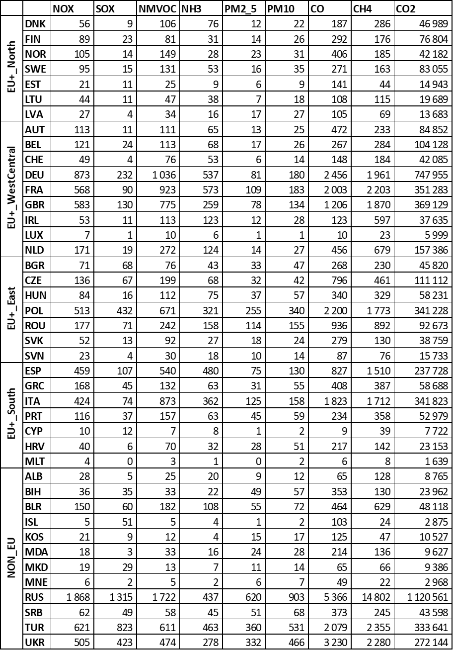
Table 2.3: Total emissions from CAMS-REG-v6.1 by country and sea region^{a)} for the year 2020 (Gg/yr);

^{a)} Sea regions
*ATL includes also Barents Sea (BAR), Greenland Sea (GRS), Norwegian Sea (NWS)
**NOS includes English Channel (ENC)
***OTH (Other sea regions) includes Caspian Sea (CAS), Kara Sea (KAR), Persian Gulf (PSG)

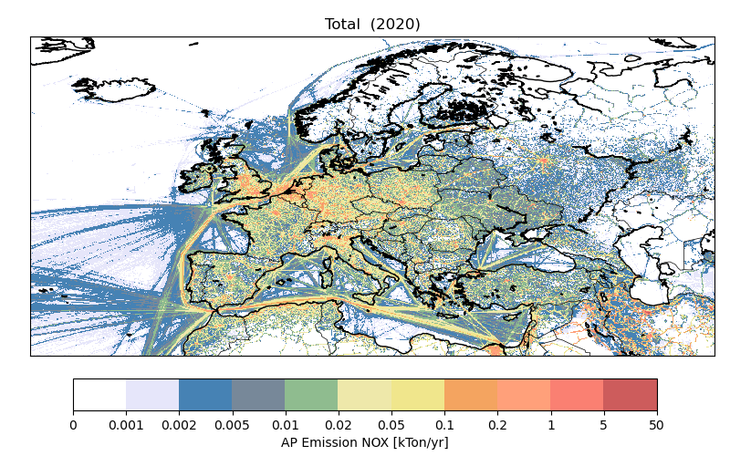
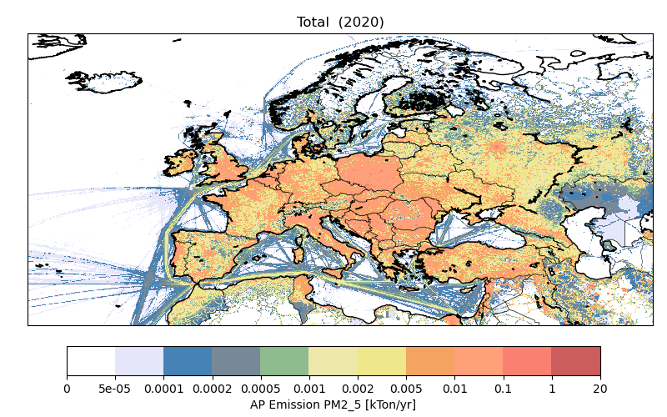
Figure 2.1: Illustration of the CAMS-REG domain and example of the gridded European CAMS-REG v6.1 emissions in 2020 for the sum of all sectors, for NOx (upper panel) and PM2.5 (lower panel).

Versions of the dataset

Multiple versions of the dataset are currently (May 2023) available:
- CAMS-REG-v2.2.1 (2000-2015), outdated and replaced by v4.2
- CAMS-REG-v3.1 (2016), outdated and replaced by v4.2
- CAMS-REG-v4.2 (2000-2017), outdated and replaced by v5.1
- CAMS-REG-v5.1 (2000-2018)
- CAMS-REG-v6.1 (2019 & 2020)

CAMS-REG-v6.1 is the latest version which was released to the CAMS regional production teams in December 2023. All the CAMS-REG datasets are, or will be, publicly available.

Since CAMS-REG-v6.1 does not include all the historical years, a direct comparison for a single year with v5.1 is not possible. However, an indication of the differences is provided in Table 2.4 which compares 2019 and 2020 from CAMS-REG-v6.1 to 2017 and 2018 from CAMS-REG-v5.1. This comparison only includes land-based emissions, hence excluding international shipping. The differences between years represents the actual trends in emissions, e.g. reductions in NOx and SOx due to improved technology in transport and stationary combustion sectors, respectively. The comparison between 2018 and 2019 in Table 2.4 however, may also include methodological differences due to the use of different reporting years. Overall, these differences are small, but when zooming in to specific countries the differences may be significant. These differences are typically caused by changes in reporting and methodological differences in the different country inventories. As a result, the comparison between 2018 and 2019 emissions is indicative and small deviations cannot be excluded. This will be corrected in a future version of CAMS-REG that will provide a complete time series.

A final observation that can be made is the larger reduction in 2020 compared to 2019, which can be attributed to Covid-19 pandemic. This can be seen e.g. for NOx which decreased around twice as much as the years before. Also, CO and CO2 emissions are reduced more than average. For other pollutants however, these Covid-related emission changes are fairly small in the country average. Mainly because the main sources of these pollutants, like agriculture, were not much affected by the pandemic.

 | CAMS-REG-v5.1 |  | CAMS-REG-v6.1
Year | 2017 (kton) | 2018 | 2019 | 2020
NOX | 9842 | -4% | -9% | -18%
SOX (SO2) | 5532 | -9% | -21% | -31%
NMVOC | 10019 | -2% | -3% | -2%
CO | 21119 | -3% | -5% | -12%
NH3 | 5279 | -1% | -3% | -3%
PM10 | 3021 | -1% | -1% | -4%
PM2_5 | 1715 | -1% | -1% | -3%
CH4 | 37732 | -1% | -3% | -4%
CO2 | 5238858 | -1% | -4% | -10%
Table 2.4: Comparison between total emissions in CAMS-REG-v5.1 (2017-2018) and CAMS-REG-v6.1 (2019-2020) for all countries (excl. international shipping).
Earlier versions of the dataset are briefly described in Annex 1.

Associated datasets

Apart from the dataset described here (CAMS-REG-v6.1), two associated datasets have been developed within CAMS.

Alternative inventory for specific sources

An alternative version of CAMS-REG has been produced, where PM emissions from GNFR C (other stationary combustion) were replaced with a bottom-up estimate. This bottom-up calculation consistently includes the condensable component of PM. This alternative inventory was needed since current reporting of PM from small combustion is not consistent especially for the PM emissions from this sector. This emission dataset, often referred to as the Ref2 inventory, has been completely updated as part of a separate project (Simpson et al. 2022) for the years 2005-2019. For 2020, the trend in the reported emission data from the regular CAMS-REG-v6.1 dataset as described here has been used to calculate the Ref2 emissions for this particular year. This dataset is referred to as CAMS-REG-v6.1-Ref2-v2.1, available for the years 2019 and 2020.

Recent year emissions

There has been a request from the modelling community to have emission estimates for the most recent year, rather than having to wait 2 or more years for the official inventories to become available. To bridge this gap, a methodology has been developed by TNO to extend the time series by 1 or 2 years using early available data, and extrapolation of emissions looking both at the drivers (energy consumption, production rates) as well as trends in technologies (affecting emission factors, such as fleet renewal and abatement installed).

For this purpose, the CAMS-REG-v6.1-Ref2-v2.1 dataset (including the alternative PM inventory for GNFR C described in section 2.4.1) has been extrapolated to 2021 and 2022. Specific features included in this work are specific emission reductions in 2021 due to the Covid-19 pandemic in road transport and aviation. Moreover, specific emission changes due to the energy crisis in 2022 were estimated. These arise mostly from an increased amount of wood being used for residential heating to replace the relatively expensive fossil fuels in 2022.

References

Guevara, M., Petetin, H., Jorba, O., Denier van der Gon, H., Kuenen, J., Super, I., Jalkanen, J.-P., Majamäki, E., Johansson, L., Peuch, V.-H., and Pérez García-Pando, C.: European primary emissions of criteria pollutants and greenhouse gases in 2020 modulated by the COVID-19 pandemic disruptions, Earth Syst. Sci. Data, 14, 2521–2552, https://doi.org/10.5194/essd-14-2521-2022, 2022.

Kuenen, J., Dellaert, S., Visschedijk, A., Jalkanen, J.-P., Super, I., and Denier van der Gon, H.: CAMS-REG-v4: a state-of-the-art high-resolution European emission inventory for air quality modelling, Earth Syst. Sci. Data, 14, 491–515, https://doi.org/10.5194/essd-14-491-2022, 2022.

Simpson, D., Kuenen, J., Fagerli, H., Heinesen, D., Benedictow, A., Denier van der Gon, H., Visschedijk, A., Klimont, Z., Aas, W., Lin, Y., Yttri, K., Paunu, V.: Revising PM2.5 emissions from residential combustion, 2005-2019: implications for air quality concentrations and trends. Report for the Nordic Council of Ministers, https://pub.norden.org/temanord2022-540, 2022.

The CAMS global anthropogenic emissions: CAMS-GLOB-ANT

Authors: Claire Granier, Antonin Soulie, Cathy Liousse

Methodology

The version of the CAMS-GLOB-ANT described in this document is version 6.1, i.e. the global anthropogenic emissions dataset delivered in March 2023.
This version of the CAMS global anthropogenic emissions is based on the emissions provided by versions 5, 6 and 7 of the EDGAR inventory developed by the European Joint Center (JRC), as well as version 4.3.2 for the VOCs speciation, available at: https://edgar.jrc.ec.europa.eu/dataset_ap50) and the CEDS emissions which provide emissions for the next IPCC report, AR6: we have used the version of the CEDS emissions released in April 2021, available at: https://doi.org/10.5281/zenodo.3606752, based on the paper of McDuffie et al. (2020).
Characteristics of these datasets are shown in Table 3.1. The dataset is also detailed in deliverable D81.2.2.1.

Name of inventory | Species considered | Period covered | Spatial resolution
EDGARv5 | BC, OC, NOx, NH3, SO2,  NMVOCs, CO, CH4 and N2O only road transportation sector | 1970-2015 | 1/10ºx1/10º
EDGARv6 | BC, OC, NOx, NH3, SO2,  NMVOCs, CO, CH4 and N2O | 1970-2018 | 1/10ºx1/10º
EDGARv7 | CO2 (excluding short cycle and organic cycle) | 1970-2021 | 1/10ºx1/10º
CEDS  version April 2021 | BC, OC, NO_{x}, NH₃, SO₂,  NMVOC, CO, CH₄, CO2 | 1750-2019 | per country and IPCC sector
EDGARv4.3.1 | Speciated VOCs | 1970-2012 | 1/10
REASv3.2 | BC, CO, CO2, NH3, NMVOCs, NOx, OC, SO2 | 1950-2015 | Only China emissions used here
Table 3.1: Datasets used to develop the 2000-2023 CAMS-GLOB-ANT_v6.1 global emissions.

As the methodology to develop version 6.1 of the CAMS-GLOB-ANT inventory is based on the use of the CEDS emissions to extrapolate the EDGARv6 or v7 emissions to 2023, the first step has been to find a good correspondence between the sectors in the EDGARv6/7 dataset and the CEDS non-gridded emissions released in April 2021. Table 3.2 shows the correspondence between the sectors of the datasets used. The first column shows the sectors in the CAMS-GLOB-ANT_v6.1 dataset. The right column gives the names of the species for which emissions for each sector are available.
In order to extrapolate the EDGAR emissions from 2018 (or 2021 for CO2) to 2023, trends in the emissions for each species, sector and country are calculated using the CEDS emissions. This trend is calculated using the 2014-2019 country data from CEDS. A geometrical extrapolation is then used based on the trend for each country: the trend is applied to each grid point located in each country.
As the REAS trends are in a better agreement with the other inventories in the Chinese region, this inventory is used to extrapolate emissions in China, when the species and sector are available. The trend is calculated on the 2012-2015 period.

For the road transportation sector, CO emissions in EDGARv6 are much lower than in other inventories, and it was decided to use for now the EDGARv5 road transportation emissions.
Concerning the sectors, one change was implemented in version 6.1 of CAMS-GLOB-ANT, at the request of the CoCO2 (Copernicus CO2) project: the energy sector was split into two sectors, as indicated in Table 3.2. This will allow a better analysis of the point sources related to power plants. In addition, the residential and commercial sector “res” was split into a domestic sector “res” and a commercial sector “com” in order to better assess the impact of COVID-19 lockdowns on emissions.

For the individual VOCs emissions, no CEDS data are available. The only published data on individual VOCs are available until 2012 from a previous version of EDGAR. As the trends in individual VOCs have likely changed during the past ten years, we have based our extrapolation on the emissions of the NMVOCs species. We have calculated the trend in the emissions for this species over the 2012-2019 period from the CEDS emissions. Table 3.3 shows the sectors for which emissions are provided for VOCs.
Table 3.2: Sector correspondence between CAMS-GLOB-ANT, EDGARv5 and CEDS for the different species.

Table 3.2: Continued.

Real name | ENE | IND | RCO | TRO | TNR | FEF | SLV | AWB | SHP | SWD
Alcohols
Ethane
Propane
Butanes
Pentanes
Hexanes
Ethene
Propene
Acetylene
Isoprene
Monoterpenes
Other alkad.
Benzene
Toluene
Xylenes
Trimethylbenzenes
Other aromatics
Esters
Ethers
Chlorinated
Methanal
Other alkanals
Alkanones
Acids
Others

Table 3.3: List of VOCs considered in the inventory and corresponding sectors.

For the ship emissions, we have used the most recent version of CAMS-GLOB-SHIP, which provides daily variations of emissions due to shipping from 2000 to 2021. This inventory is divided in 2 sectors (inland and global sea navigation) which have been merged. The species included in the CAMS-GLOB-SHIP dataset are CO2, CH4, CO, NOx, NMVOCs, SO2, OC and BC. The last year has been repeated up to 2023. For the ship emissions of the speciated VOCs, a yearly-averaged ratio between the total VOCs ship emissions from EDGARv6 and from each individual VOC from EDGARv4.3.2 has been calculated. The total NMVOCs ships monthly emissions from CAMS-GLOB-SHIP are then multiplied by this ratio for each year to obtain the emissions of each individual VOC from shipping.

After being calculated on a yearly time resolution, the CAMS-GLOB-ANTv6.1 emissions are calculated on a monthly-basis. When available, the monthly variations provided by CAMS-GLOB-TEMPO are used. i.e.:

Finally, the effects of the COVID-19 lockdowns on the 2020 emissions are taken in account using the CONFORM dataset. CONFORM provides gridded adjustment factors representing the emissions changes due to lockdowns. The CONFORM adjustment factors are on a daily timestep, so they are then averaged on the month to match the CAMS-GLOB-ANT timestep.

Emissions provided by the CAMS-GLOB-ANT_6.1 inventory
The 2000-2023 global anthropogenic emissions have been developed, as described in the previous section. The emissions are provided on a monthly basis for a large number of species, CO₂, CH₄, N₂O, BC, OC, SO₂, CO, NOx, NH₃, as well as NMVOCs and 25 individual VOCs. As an example of the spatial distribution of the emissions, Figures 3.1 to 3.4 show the January 2023 emissions for CO and NOx, for BC and OC emissions, for SO₂ and NH₃ emissions, and for NMVOCs and ethane, respectively. Note that the colour scales are different for all the species in these figures.
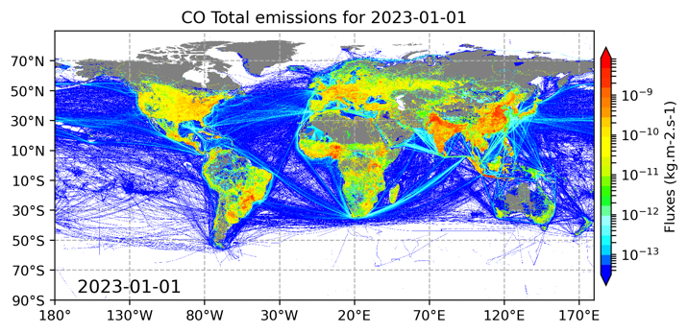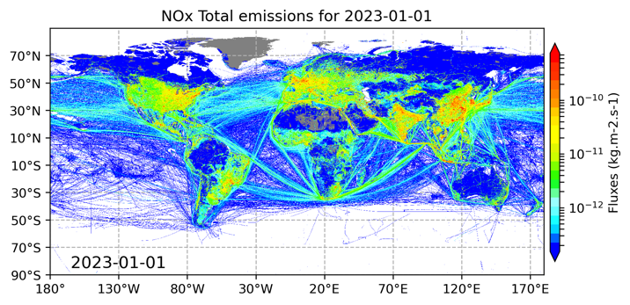
Figure 3.1: CO (left) and NOx (right) total emissions in January 2023 from all sectors.
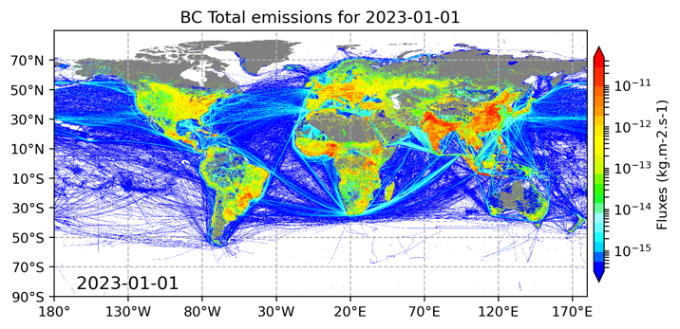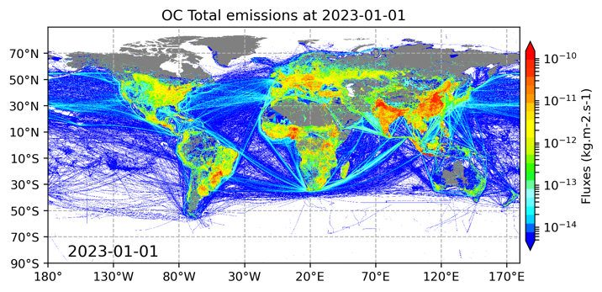
Figure 3.2: BC (left) and OC (right) total emissions in January 2023 from all sectors.
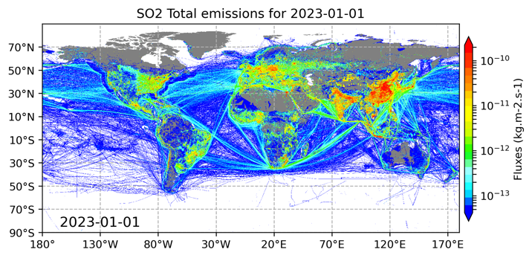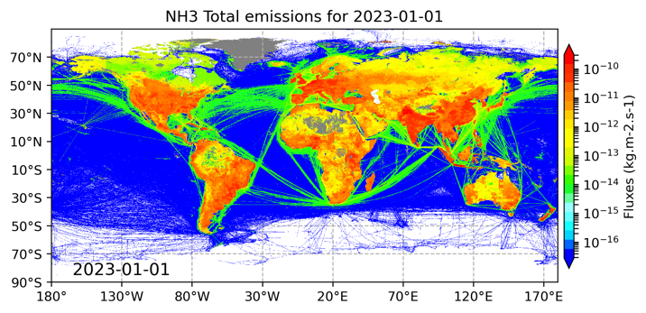
Figure 3.3: SO2 (left) and NH3 (right) total emissions in January 2023 from all sectors.
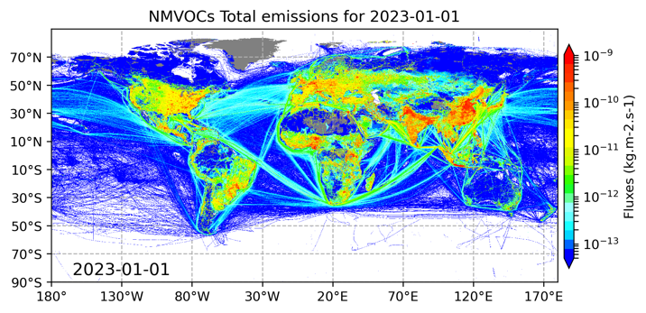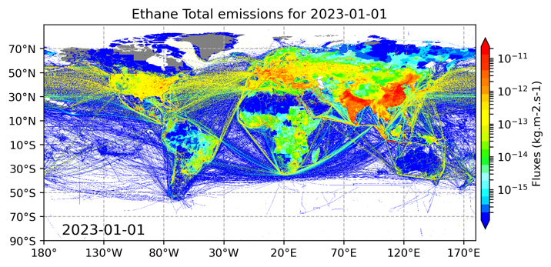
Figure 3.4: NMVOCs (left) and Ethane (right) total emissions in January 2023 from all sectors.

Versions of the dataset

This version of the 2000-2023 global anthropogenic emissions is called CAMS-GLOB-ANT_v6.1.

Earlier versions of the dataset are briefly described in Annex 1.

References

McDuffie, E. E., Smith, S. J., O'Rourke, P., Tibrewal, K., Venkataraman, C., Marais, E. A., Zheng, B., Crippa, M., Brauer, M., and Martin, R. V.: A global anthropogenic emission inventory of atmospheric pollutants from sector- and fuel-specific sources (1970–2017): an application of the Community Emissions Data System (CEDS), Earth Syst. Sci. Data, 12, 3413–3442, https://doi.org/10.5194/essd-12-3413-2020, 2020.

The CAMS ship emissions: CAMS-GLOB-SHIP

Author: Jukka-Pekka Jalkanen

Methodology

Emissions originating from global shipping traffic were modelled using the Ship Traffic Emission Assessment Model (STEAM, Johansson et al., 2017; Jalkanen et al., 2016), which uses Automatic Identification System (AIS) data to describe ship traffic activity. Nowadays, all vessels larger than the 300 tons size limit globally report their position with a few seconds intervals; this has resulted in an availability of information on ship activities at an unprecedented level of detail (Jalkanen et al., 2016). The ship emission inventories, which are based on such automated identification systems, have several significant advantages over the previously developed approaches. The CAMS ship inventory is therefore based on time-dependent, high-resolution dynamic traffic patterns, which can also allow for the effects of changing conditions, such as, e.g., marine and meteorological conditions (e.g., harsh winter conditions and sea ice cover), or weather routing. The ambient contributions from sea ice cover, winds, waves and sea currents are currently included in the ship emission modelling, whereas contributions from biofouling are described in a simplistic manner. These contributions are included in STEAM via existing algorithms available in the literature (Townsin et al, 1993; Blendermann et al, 1993; Riska et al, 1997) and Copernicus atmospheric/marine datasets.

Disruptions, like the global COVID19 pandemic are considered, because the underlying activity data is based on observed ship locations. Changes in environmental regulation of the shipping sector have been included at global and regional levels. These include establishment of Emission Control Areas for SOx and NOx in the Baltic Sea, North Sea and North America as well as Chinese domestic ECAs and vessel type specific rules for ships operating in European seas. Global Sulphur cap became effective on Jan 1st 2020, which decreased SOx and PM emissions, but ECAs were unaffected by the cap because ECAs have had similar rules in effect for several years already.

The model output can be utilised in regional air quality models on an hourly basis and can also be used to assess the impacts of miscellaneous emission abatement scenarios (e.g., changes of fuel grade, the introduction of scrubbers and slow-steaming scenarios). A new model version of STEAM (v4.1.1) has been used to generate this data. This model version adds methane from gas-fuelled engines as a new pollutant, revises the auxiliary engine profiles, updates emission factors, uses UNFCCC allocation of shipping to international and domestic parts and considers ambient effects in emission modelling.

For projections, vessel size growth and energy efficiency improvements have been considered as well as the introduction of IMO (International Maritime Organization) NOx Tiers when old vessels are replaced by new ships, these features have an impact on inventories which are either forecasts or a modelled approximation of historic developments. Ammonia and methanol as marine fuels have been added to scenario tools.

For those years, where activity data is available, actual data for the global ship fleet and its activity are used. The main challenge for the global emission modelling of shipping is the treatment of the large number of vessels operating globally, for which it is difficult to obtain technical vessel specifications. In CAMS ship emission inventory construction, fleet description of IHS Markit is used. In the event of data gaps in fleet description, a match to the most similar vessel is used. Further details can be extracted using a web crawler and searching the internet to complete the missing technical details (Johansson et al, 2017). Another issue is the sparsity of satellite-based AIS-data which makes it necessary to analyse individual route segments and occasionally apply advanced route generation algorithms.

The same methodology is used for calculating the global and regional emissions from shipping: therefore, ship emissions for the European domain and ship emissions at the global scale are fully consistent. An example of the CO₂ emitted from ships in 2020 is shown in Figure 4.1.

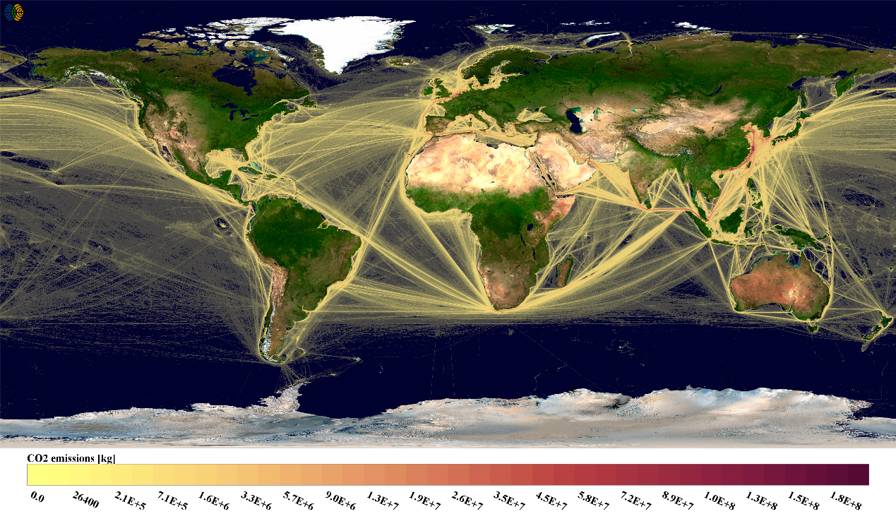
Figure 4.1: Global CO₂ emissions from ships in 2020

CAMS-GLOB-SHIP emission inventories for 2014-2021 are based on observed vessel traffic from those years. The earlier years (2000-2013) are based on back casting the 2016 vessel activity and assumed changes in vessel efficiency, vessel numbers and size. Meteorological data from earlier years (2000-2013) are used in back casting of ship emissions. The back casted data for 2000-2013 have been rerun with the updated STEAM version (v4.1) to provide a consistent dataset from 2000 onwards.

Emissions data

Emission files are provided in NetCDF/CF conventions format and contain daily emission totals of NO_{x}, SO_{x}, CO, CO₂, NMVOC, CH₄, EC, OC, Ash and SO₄. The last four species form the dry Particulate Matter (PM) inventory, size range less than 2.5 micrometers.

Versions of the dataset

The current version of the 2000-2021 global anthropogenic emissions is called CAMS-GLOB-SHIP_v3.2. Earlier versions of the dataset are briefly described in Annex 1.

References

Blendermann, W.: Parameter identification of wind loads on ships, J. Wind Eng. Ind. Aerodyn., 51, 339, 1993.

Jalkanen, J.-P. P., Brink, A., Kalli, J., Pettersson, H., Kukkonen, J., Stipa, T., … Stipa, T. (2009). A modelling system for the exhaust emissions of marine traffic and its application in the Baltic Sea area. Atmos. Chem. Phys., 9(4), 9209–9223. https://doi.org/10.5194/acp-9-9209-2009

Jalkanen, J. P., Johansson, L., Kukkonen, J., Brink, A., Kalli, J., & Stipa, T. (2012). Extension of an assessment model of ship traffic exhaust emissions for particulate matter and carbon monoxide. Atmospheric Chemistry and Physics, 12(5), 2641–2659. https://doi.org/10.5194/acp-12-2641-2012

Johansson, L., Jalkanen, J.-P., Kalli, J., & Kukkonen, J. (2013). The evolution of shipping emissions and the costs of regulation changes in the northern EU area. Atmospheric Chemistry and Physics, 13(22), 11375–11389. https://doi.org/10.5194/acp-13-11375-2013

Jalkanen, J.-P., Johansson, L., and Kukkonen, J.: A comprehensive inventory of ship traffic exhaust emissions in the European sea areas in 2011, Atmos. Chem. Phys., 16, 71-84, https://doi.org/10.5194/acp-16-71-2016, 2016.

Johansson, L., J.-P. Jalkanen, and J. Kukkonen, Global assessment of shipping emissions in 2015 on a high spatial and temporal resolution, Atm. Env., 167, 403-415, doi: 10.1016/j.atmosenv.2017.08.042

Riska, K., Wilhelmson, M., Englund, K. and Leiviskä, T.: Performance of merchant vessels in ice in the Baltic, Winter Navigation Board., 1997.

Townsin, R. L. ., Kwon, Y. J. ., Baree, M. S. . and Kim, D. Y. .: Estimating the influence of weather on ship performance, RINA Trans., 135, 191–209, 1993.

The CAMS aircraft emissions: CAMS-GLOB-AIR

Authors: Claire Granier

Methodology

Aircraft emissions are based on the CEDS aircraft emission data as described in Hoesly et al. (GMD, 2018). For the years up to 2014, the emissions are the same as CEDS. After 2014, we extrapolate in time up to 2021 using the trends calculated for the period 2012-2014. These dates were chosen because the trends are more stable after 2011.

For the speciation of VOCs, the emissions are based on the weights defined by EDGAR for landing and taking off (for the first two levels of the atmosphere corresponding to 0.305 km and 0.915 km), and for exhaust (corresponding to the rest of the levels up to 14.945 km). The emission for each individual VOC is calculated by multiplying these weights by the emissions for total VOCs.

Emissions data

Aircraft emissions are provided on a 0.5º X 0.5º in longitude and latitude spatial resolution for 25 altitude levels, covering the period 2000-2021. An example of the NOx aircraft emissions in April 2021 at a 10.6 km altitude is shown in Figure 5.1.

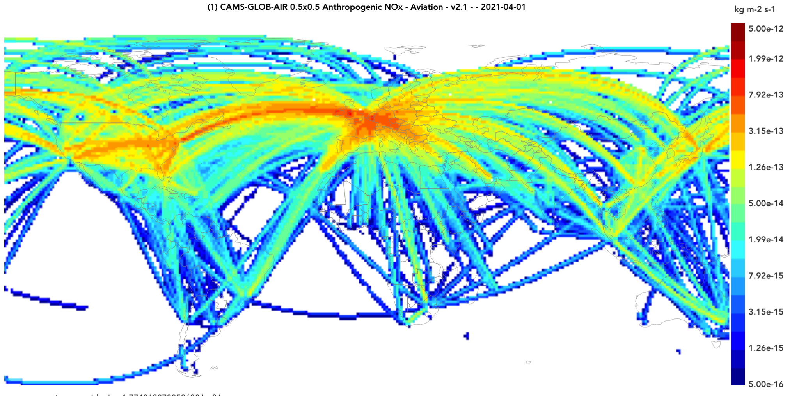

Figure 5.1: NOx emissions from aircraft at 10.6 km in April 2021.

Versions of the dataset

The current version of the 2000-2020 global anthropogenic emissions is called CAMS-GLOB-AIR_V1.1. It provides emissions from 2000 to 2021.

References

Hoesly, R. M., Smith, S. J., Feng, L., Klimont, Z., Janssens-Maenhout, G., Pitkanen, T., Seibert, J. J., Vu, L., Andres, R. J., Bolt, R. M., Bond, T. C., Dawidowski, L., Kholod, N., Kurokawa, J.-I., Li, M., Liu, L., Lu, Z., Moura, M. C. P., O'Rourke, P. R., and Zhang, Q.: Historical (1750–2014) anthropogenic emissions of reactive gases and aerosols from the Community Emissions Data System (CEDS), Geosci. Model Dev., 11, 369-408, https://doi.org/10.5194/gmd-11-369-2018, 2018.

The CAMS anthropogenic temporal profiles: CAMS-TEMPO

Authors: Marc Guevara Vilardell

Methodology

The CAMS-TEMPO dataset consists of a collection of global and European regional temporal factors that follow the domain description (resolution and geographical area covered) and sector classification reported by the CAMS-GLOB-ANT and CAMS-REG-AP/GHG emission inventories. To better distinguish between the two sets of profiles, we refer to them as CAMS-GLOB-TEMPO (global temporal profiles associated to the CAMS-GLOB-ANT inventory) and CAMS-REG-TEMPO (regional European temporal profiles associated to the CAMS-REG-AP/GHG inventory).

The following features are considered in the CAMS-TEMPO profiles:
- Pollutant-dependency: For some sectors, profiles were computed for all species independently in order to account for the variability of the activity patterns.
- Spatial variability: For almost all sectors, the temporal profiles are made country or even country and region-specific in order to take into account the effects of different sociodemographic patterns and climatology conditions, among other factors.
- Meteorological influence: For some sectors, the profiles were constructed using meteorological-dependent parametrizations (e.g., heating degree day approach) to account for the emissions variability driven by temperature or wind speed.

The dataset includes monthly, weekly (day-of-the-week), daily (day-of-the-year) and diurnal temporal profiles for the priority air pollutants (NO_{x}, SO₂, NMVOC, NH₃, CO, PM₁₀, PM_{2.5}) and the greenhouse gases (CO₂ and CH₄) and for the following anthropogenic source categories: energy industry, refineries (only for CAMS-GLOB-TEMPO) residential combustion, manufacturing industry, road transport, aviation (landing and take-off cycles, only for CAMS-REG-TEMPO), shipping (only for CAMS-REG-TEMPO), other mobile sources (only for CAMS-REG-TEMPO) and agriculture (fertilizers, livestock and agricultural waste burning). Depending on the pollutant source and temporal resolution, the resulting profiles are reported as spatially invariant (i.e., a unique set of temporal weights for all the domain) or gridded values (i.e., temporal weights vary per grid cell). The spatial resolution of the gridded profiles is 0.1° x 0.1° for CAMS-GLOB-TEMPO and 0.1° x 0.05° for CAMS-REG-TEMPO. In the case of CAMS-REG-TEMPO, the domain covered by the dataset is: 30° W – 60° E and 30° N – 72°N. For both temporal profile datasets, the sum of all weight factors is equal to 12 for monthly profiles, 7 for weekly profiles, 365 or 366 (in case of a leap year) for daily profiles and 24 for hourly profiles.

The following tables summarize the characteristics of each temporal profile included in the latest versions of the CAMS-GLOB-TEMPO and CAMS-REG-TEMPO datasets (version 4.1), respectively.

Table 1: Main characteristics of the CAMS-GLOB-TEMPOv4.1 dataset reported by sector and temporal resolution (monthly, daily, weekly, hourly). Per country: indicates that the profiles vary per country; per pollutant: indicates that the profiles vary per pollutant; per grid cell: indicates that the profiles vary per grid cell within a country; fixed: indicates that the profiles are spatially invariant. The symbol “-“ denotes that no profile is proposed.
Sector | Description | Monthly  (∑=12) | Daily  (∑=365/366)⁽¹⁾ | Weekly  (∑=7) | Hourly  (∑=24)
ene | Power generation | (per country, pollutant) | - | (per country, pollutant) | (per country, pollutant)
ref | Refineries | (per country) | - | (fixed)⁽²⁾ | (fixed)⁽²⁾
ind | Industrial process | (per country) | - | (fixed)⁽²⁾ | (fixed)⁽²⁾
res | Other stationary combustion | (per grid cell, year) | (per grid cell, year) | (fixed)⁽²⁾ | (per grid cell, pollutant)
fef | Fugitives | (fixed)⁽²⁾ | - | (fixed)⁽²⁾ | (fixed)⁽²⁾
slv | Solvents | (fixed)⁽²⁾ | - | (fixed)⁽²⁾ | (fixed)⁽²⁾
tro | Road transportation | (per grid cell, year for CO) | - | (per country) | (per day type and country)
shp | Ships | - | - | - | -
tnr | Off road transportation | (fixed)⁽²⁾ | - | (fixed)⁽²⁾ | (fixed)⁽²⁾
swd | Solid waste and waste water | (fixed)⁽²⁾ | - | (fixed)⁽²⁾ | (fixed)⁽²⁾
agl | Agriculture livestock | (per grid cell, year for NH₃ and NO_{x}; fixed for others) | (per grid cell, year for NH₃ and NO_{x}) | (fixed)⁽²⁾ | (fixed)⁽²⁾
awb | Agriculture waste burning | (per country) | - | (fixed)⁽²⁾ | (fixed)
ags | Agriculture soil | ((per grid cell, year for NH₃; per grid cell for CH₄⁽³⁾) | (per grid cell, year for NH₃) | (fixed)⁽²⁾ | (fixed)⁽²⁾
⁽¹⁾ Leap or non-leap years
⁽²⁾ Same profiles as the ones reported by the TNO dataset (Denier van der Gon et al., 2011)
⁽³⁾ Same profiles as the ones reported by Crippa et al. (2020)

Table 2: Main characteristics of the CAMS-REG-TEMPOv4.1 dataset reported by sector and temporal resolution (monthly, daily, weekly, hourly). Per country: indicates that the profiles vary per country; per pollutant: indicates that the profiles vary per pollutant; per grid cell: indicates that the profiles vary per grid cell within a country; fixed: indicates that the profiles are spatially invariant. The symbol “-“ denotes that no profile is proposed.
Sector | Description | Monthly  (∑=12) | Daily  (∑=365/366)⁽¹⁾ | Weekly  (∑=7) | Hourly  (∑=24)
GNFR_A | Public Power | (per country, pollutant) | - | (per country, pollutant) | (per country, pollutant)
GNFR_B | Industry | (per country) | - | (fixed)⁽²⁾ | (fixed)⁽²⁾
GNFR_C | Other stationary combustion | (per grid cell, pollutant, year) | (per grid cell, pollutant, year) | (per pollutant) | (per pollutant)
GNFR_D | Fugitive | (fixed)⁽²⁾ | - | (fixed)⁽²⁾ | (fixed)⁽²⁾
GNFR_E | Solvents | (fixed)⁽²⁾ | - | (fixed)⁽²⁾ | (fixed)⁽²⁾
GNFR_F1 | Road transport exhaust gasoline | (per year, grid cell for CO and NMVOC; per grid cell for others) | - | (per country) | (per country, day type)
GNFR_2 | Road transport exhaust diesel | (per year, grid cell for NO_{x}; per grid cell for others) | - | (per country) | (per country, day type)
GNFR_F3 | Road transport exhaust LPG | (per grid cell) | - | (per country) | (per country, day type)
GNFR_F4 | Road transport non-exhaust (wear and evaporative) | (per grid cell) | - | (per country) | (per country, day type; fixed for NMVOC)
GNFR_G | Shipping | (per sea region and pollutant) | - | (fixed)⁽²⁾ | (fixed)⁽²⁾
GNFR_H | Aviation | (per country) | - | (per country) | (fixed)
GNFR_I | Off road transport | (fixed, per pollutant) | - | (fixed, per pollutant) | (fixed, per pollutant)
GNFR_J | Waste management | (fixed)⁽²⁾ | - | (fixed)⁽²⁾ | (fixed)⁽²⁾
GNFR_K | Agriculture (livestock) | (per grid cell, year for NH₃ and NO_{x}; fixed for others) | (per grid cell, year for NH₃ and NO_{x}) | (fixed)⁽²⁾ | (fixed)⁽²⁾
GNFR_L | Agriculture (fertilizers, agricultural waste burning) | (per country for CH₄, per country for others)⁽³⁾ | (per grid cell, year for NH₃) | (fixed)⁽²⁾ | (fixed, per pollutant)
⁽¹⁾ Leap or non-leap years
⁽²⁾ Same profiles as the ones reported by the TNO dataset (Denier van der Gon et al., 2011)
⁽³⁾ For CH₄, same profiles as the ones reported by Crippa et al. (2020)

The following subsections briefly describe the input data and methodologies used to compute the CAMS-TEMPO_v4.1 emission temporal profiles for each targeted sector.

Energy industry

The temporal variability of emissions from the industrial energy sector was estimated from national electricity production statistics after assuming that it depends to a large extent upon the combustion of fossil fuels in power and heat plants. This approximation is perfectly consistent with the definition of the GNFR sector “A_PublicPower” in the CAMS-REG_AP and “ene” CAMS-GLOB_ANT datasets, as they only include emissions from these types of facilities.

The dataset compiled to derive temporal profiles for this sector includes energy production data for the years 2017 to 2019 from multiple sources of information, including:
- Europe: The ENTSO-E Transparency Platform (Hirth et al., 2018; ENTSOE, 2021 )
- Russia: System Operator of the United Power System (SO-UPS, 2021)
- Ukraine: National Energy Company Ukrenergo (UNEC, 2021)
- North America: The Continuous Emissions Monitoring (CEM) inventory, obtained from the US EPA emission modelling platform (US EPA, 2021)
- Mexico: The national Centre of Energy Control (CENACE, 2021)
- Chile: The National Energy Commission (CNE, 2021)
- United Arab Emirates: The Dubai Electricity & Water Authority (DEWA, 2021)
- Kuwait: Ministry of Electricity and Water (MEW) through Alhajeri et al. (2018)
- Oman: National Center for Statistics and Information (NCSI, 2021)
- Thailand: Electricity Generating Authority of Thailand (EGAT, 2021)
- Peru: Peruvian Committee for Economic Operation of the System (COES, 2021)
- India: National Power Portal (NPP, 2021)
- South Africa: Electricity Supply Commission (ESKOM, 2021)
- Nigeria: Nigerian Electricity Regulatory Commission (NERC, 2021)
- Turkey: Turkish Electricity Transmission Corporation (TEIAS, 2021)
- Australia: Australian Energy Market Operator (AEMO, 2021)
- Other countries: The International Energy Agency monthly electricity statistics (IEA, 2021) .

The efforts to compile and process such an extensive dataset of information was done combining efforts from CAMS_81 and the CoCO2 H2020 project.

Pollutant-related profiles were derived for all those countries where the reports of electricity production were split by fuel. Hence, monthly factors were derived by averaging the available production data per month and relating them to the total production in the year. For countries with no information, averaged profiles from countries belonging to the same world region were used. The definition of world regions was taken from the EDGARv5 emission inventory (Crippa et al., 2018).

Residential/Commercial combustion

The temporal release of emissions from the residential combustion sector was assumed to be caused by the stationary combustion of fossil fuels in households and commercial buildings. These two source categories are assumed to be the main contributors to total emissions from the “Residential heating (res)” and the “C_OtherStationaryComb” sectors reported by the CAMS-GLOB_ANT and the CAMS-REG_AP/GHG inventories, respectively. Other combustion installation activities covered by these two sectors (i.e., plants in agriculture/forestry/aquaculture and other stationary) are assumed to follow the same temporal profile.

Gridded daily temporal profiles were derived according to the heating Degree Day (HDD) concept, which is an indicator used as a proxy variable to reflect the daily energy demand for heating a building (Quayle and Diaz, 1980). The profiles were developed for 22 years (i.e., 2000 to 2022) using the daily mean 2m outdoor temperature reported by the ERA5 reanalysis dataset (C3S, 2017) and considering a base temperature of 15.5 Celsius degrees. A constant offset was also considered to account for those combustion processes not related to space heating but also to other activities that remain constant throughout the year such as water heating or cooking. The value of this constant offset is assumed to be 0.1 for PM10 and PM2.5 and 0.2 for the other pollutants for CAMS-REG-TEMPOv4.1, based on the European household energy statistics reported by Eurostat (2018, which indicates that approximately 90% of solid fuels (coal) and biofuels (wood) are used for space heating, whereas in the case of natural gas this value is a bit lower (close to 80%). For CAMS-GLOB-TEMPOv4.1, we assume a constant offset value of 0.2, as the use of solid biofuels for space heating can significantly vary across world regions, being close to 20% or less in certain regions such as India, parts of China or South Africa, as reported in the CAMS_81 deliverable (CAMS81_2020SC1_D81.6.6.1_202008_v1).

Monthly gridded factors were also derived from the daily profiles for all the years available (2000 to 2022).

The daily profiles computed with the HDD approach were also used to derive a climatological weekly profile for PM10 and PM2.5 residential combustion emissions, which are mainly linked to wood combustion. The weekly profile was computed considering only cold months (i.e., January to March and October to December), when emissions are at their maximum and mainly driven by changes in the outdoor temperature. The resulting weekly profile suggests a flat distribution of emissions, which is in line with the profiles proposed by the GENEMIS dataset for this sector and other recent works (e.g., Lopez-Aparicio et al., 2022). For the other pollutants, we consider the weekly profile proposed by TNO, which reports a -25% decrease in weekend emissions compared to weekdays, as other fuels than biomass (e.g., natural gas) are associated to combustion processes not only in households but also in commercial and public buildings, which typically reduce their activity during weekends regardless of changes in the outdoor temperature.

The diurnal behaviour of residential combustion emissions varies according not only to the fuel but also the type of end-use (i.e., space heating or cooking). Subsequently, the following region- and pollutant-dependent diurnal profiles are proposed:

- Developed countries:
  - For all pollutants except PM10, PM2.5, CO, CO₂ and CH₄ in urban/rural areas: use the MACC profile reported for SNAP02.
  - For PM10, PM2.5, CO, CO₂ and CH₄ in urban/rural areas: use an average of reported profiles linked to the combustion of residential wood (i.e., Finstad et al., 2004; Makkonen et al., 2011; and Athanasopoulou et al., 2017).

- Developing countries:
  - for all pollutants except PM10, PM2.5, CO, CO₂ and CH₄ in urban areas: use the MACC profile reported for SNAP02
  - for PM10, PM2.5, CO, CO₂ and CH₄ in urban areas: use an average of reported profiles linked to the combustion of residential wood (i.e., Finstad et al., 2004; Makkonen et al., 2011; and Athanasopoulou et al., 2017).
  - for all pollutants in rural areas, use profiles derived from measurements performed in households in the eastern Tibetan Plateau (Carter et al., 2016).

The assignation of the profiles was done under the following assumptions:
- PM10, PM2.5, CO, CO2 and CH4 emissions are mainly linked to wood combustion.
- In urban and rural areas of developed countries wood is mainly used for heating purposes.
- In urban areas of developing countries wood is mainly used for heating purposes.
- In rural areas of developing countries all fuels are used both for heating and/or cooking purposes (i.e., the two activities occur at the same time).

Manufacturing industry

The temporal variability of industrial emissions focuses on the manufacturing sector, as the contribution from these facilities dominates the total emissions. Both in the CAMS-GLOB_ANT and the CAMS-REG_AP/GHG inventories, all industrial emissions are reported under a single category (i.e., “Industrial processes (ind)” and “B_Industry”, respectively). Hence, the same temporal pattern has to be assumed for all types of facilities (e.g., cement plants, iron and steel plants).

Country-specific monthly profiles were estimated using the Industrial Production Index (IPI), which measures the monthly evolution of the productive activity of different industrial branches; that is, of the extractive, manufacturing, and production and distribution activities of electricity, water and gas. The IPI data was obtained from the MBS database (https://unstats.un.org/unsd/mbs/), which provides monthly information per country for the year 2015. For countries with no information, averaged profiles from countries belonging to the same world region were used. The definition of world regions was taken from the EDGARv5 emission inventory (Crippa et al., 2018). In the case of China, and due to its important contribution to total emissions, the monthly profile reported by the MIX inventory is assumed (Li et al., 2017). The time profiles were constructed based on IPI information from 2015 and it is assumed that they can be representative for other years.

Due to the lack of country-specific data, the weekly and diurnal temporal profiles provided in the framework of the MACC projects for the SNAP03 sector are proposed.

Refineries

Previous versions of the CAMS-GLOB-ANT inventory were reporting emissions from refineries as part of the energy sector (ene), together with emissions from power plants. However, starting with CAMS-GLOB-ANT_v5.3, refinery emissions are reported separately under a dedicated sector (ref). Considering that the seasonality of emissions released from power plants and refineries can be quite different, we constructed a new set of monthly profiles for this sector.

Monthly profiles for refineries were estimated from national refinery production statistics compiled for different countries and years from multiple sources of information, including:

- Eurostat: Supply and transformation of oil and petroleum products (2013 to 2022)
- U.S. Energy Information Administration: U.S. Refinery Net Production of Crude Oil and Petroleum Products (2003 to 2022)
- Australian Petroleum Statistics: Petroleum production (2010 to 2022)
- Statistics Canada:
- Brazil’s National Agency for Petroleum, Natural Gas and Biofuels: National production of petroleum products (2000 to 2022)
- Chile’s Superintendency of Electricity and Fuels: National production of petroleum products (2011, 2013, 2015 and 2016)
- Government of India Ministry of Petroleum and Natural Gas: refinery production (2015 to 2019)

Climatological country-dependent profiles were then constructed by averaging the year-dependent profiles. Note that profiles for the years 2020 and 2021 were excluded from the averaging process due to the impact of the COVID-19 restrictions (Guevara et al., 2022). For countries with no information, a global averaged profile is considered. We did not consider averages from countries belonging to the same world region as done for other sectors, since: 1) the number of countries with available data is very limited (35) and most of them are in Europe and 2) the variation of the profiles across countries is not significant, as shown in section 3.2.

Due to the lack of country-specific data, the weekly and diurnal temporal profiles provided in the framework of the MACC projects for SNAP03 sector are proposed, following the assumption made for the manufacturing industry sector (See section 2.3).

Road transport

Road transport emissions reported by the CAMS global and regional inventories include exhaust (i.e., cold start and hot) and non-exhaust (i.e., gasoline evaporation and tyre/brake/road wear) sources. In CAMS-GLOB_ANT, all emissions are reported under a unique sector (i.e., road transport, “tro”), whereas in CAMS-REG_AP/GHG emissions are classified into four different categories (i.e., F1_RoadTransport_exhaust_gasoline, F2_RoadTransport_exhaust_diesel, F3_RoadTransport_exhaust_PG_gas and F4_RoadTransport_non-exhaust), the last one including both wear (PM10 and PM2.5) and evaporative emissions (NMVOC).
The fact that CAMS-REG-AP/GHG traffic-related emissions are classified into four different categories (discriminated by type of process and fuel), allows considering specific temporal features associated to each one of them, including the combination of changes in traffic activity data (i.e., traffic counts) and changes in ambient temperature for: (i) CO and NMVOC gasoline exhaust emissions as reported by US EPA (2015), (ii) NOx diesel emissions as reported by Keller et al. (2017) and (iii) NMVOC non-exhaust emissions as reported in Guevara et al. (2020b). On the other hand, in CAMS-GLOB-ANT all traffic emissions are reported under a single sector and subsequently the temporal emission variability is assumed to be exclusively driven by the traffic activity data, except for the case of CO, which is assumed to be driven by a combination of activity data and changes in the outdoor temperature.
A comparison between monthly variation in traffic patterns at urban and rural locations (i.e., urban streets and highways) performed by McDonald et al. (2014) and Guevara et al. (2021) highlighted that traffic regimes show differences according to the location (urban, rural) and that specific profiles should be constructed for each one of them.
The constructed monthly urban temporal profiles were derived from TomTom congestion statistics for a total of 412 cities (https://www.tomtom.com/en_gb/traffic-index/). The city level profiles were aggregated to a country level considering the annual average level of congestion and number of inhabitants of each city. As a result, 57 country-dependent monthly profiles for urban areas were constructed. On the other hand, the proposed monthly temporal profiles for rural areas are based on a wide range traffic count datasets compiled from national road administrations. For countries with no information, averaged urban and rural profiles from countries belonging to the same EDGAR world region were used. The resulting monthly profiles were allocated into a gridded domain. Each grid cell was classified as urban or rural using as a basis the information provided by the Global Human Settlement Layer (GHSL; Pesaresi and Freire, 2016).
Weekly variations in traffic patterns were constructed using the TomTom congestion statistics. As in the case of the monthly weight factors, profiles at the city level were averaged at the country level considering the annual average level of congestion and number of inhabitants of each city. The same profiles were considered for both urban and rural areas. For countries with no information, averaged profiles from countries belonging to the same EDGAR world region were used.
Hourly temporal profiles were also constructed using the TomTom congestion statistics, which were aggregated from the city level to country level as described in the previous paragraphs. Specific profiles were constructed for weekdays, Saturdays and Sundays. For countries with no information, averaged profiles from countries belonging to the same world region were used.

Aviation

Monthly temporal profiles for air traffic emissions reported under the GNFR_H category in the CAMS-REG-AP/GHG dataset were constructed using airport traffic data for the years 2011 to 2017 from the Eurostat statistics (Eurostat, 2019). Country-dependent monthly profiles were derived by aggregating the respective national airports available in the Eurostat dataset.

Weekly temporal profiles were constructed using as a basis the daily air traffic flight statistics at airports for the years 2016 to 2019 provided by EUROCONTROL (2020). Country-dependent weekly profiles were derived by aggregating the respective national airports available in the EUROCONTROL dataset. As shown in the following figure, a general decrease in air traffic activity is observed during Saturdays when compared to the other days of the week. This behaviour is especially noticeable in Scandinavian countries (e.g., Norway, NO and Sweden, SE).
Regarding the diurnal variation, we computed a fixed hourly profile based on airport traffic from the Madrid-Barajas and Barcelona-El Prat airports (AENA, personal communication).

Shipping

Monthly temporal profiles for the shipping sector (GNFR_G) were developed using as a basis the CAMS-GLOB-SHIP_v2.1 AIS-based daily emissions reported for the years 2016 to 2018. The constructed profiles are pollutant and sea region dependent. The resulting profiles are yearly independent as no strong year-to-year variation was found. The profiles were only developed for the CAMS-REG-TEMPO_v3.1 dataset, as the CAMS-GLOB-ANT_v5.1 inventory already includes the original monthly CAMS-GLOB-SHIP emissions.

We assume flat weekly and hourly profiles for this sector.

Other mobile sources

Monthly, weekly and hourly temporal weight factors for other mobile source emissions reported under the GNFR_I category in the CAMS-REG-AP/GHG dataset were constructed using as a basis the temporal profiles reported in the EMEP/EEA (2019) guidebook and the MapEIre project (https://projects.au.dk/mapeire/). The profiles reported by EMEP/EEA (2019) include temporal weight factors for the following GNFR_I subcategories: Agriculture & Forestry, Industry & Construction, Household & Gardening and Military. The weight factors for the subcategory Commercial & Institutional were derived from MapEIre as they are not included in EMEP/EEA (2019). Original subcategory profiles were averaged at the GNFR_I level by considering the contribution of each subcategory to total GNFR_I emissions. The contributions were estimated considering the 2018 EMEP official reported emission data for EU27 + UK (CEIP, 2020). As a result, pollutant-dependent profiles were constructed.

Agriculture

The CAMS-GLOB-ANT and CAMS-REG-AP/GHG emission inventories report the agricultural-related emissions in three and two separate sectors, respectively: “agriculture soil emissions (ags)”, “agriculture livestock (agl)” and “agricultural waste burning (awb)” for CAMS-GLOB-ANT, and “K_AgriLivestock” and “L_AgriOther” for CAMS-REG-AP/GHG. The “L_AgriOther” sector reports emissions from several activities, mainly fertilizer applications and agricultural waste burning.

For the livestock sector, both in the global and regional inventories, it is assumed that NH3 and NOx arise from the excreta of the animals and that they follow the same temporal pattern. The rest of pollutants are assumed to be a consequence of the animal activity (e.g., emissions of PM arise mainly from feed) and subsequently a flat profile is proposed for them.
For the “Agriculture (ags)” and “L_AgriOther” sectors, it is assumed that NH₃ emissions are mainly related to fertilizer application, while the other pollutants (i.e., NO_{x}, SO_{x}, NMVOC, CO, PM₁₀ and PM_{2.5}) are dominated by agricultural waste burning. Hence, different temporal profiles are proposed for each group of pollutants.
The monthly gridded distribution of NH₃ emissions from fertilizer application is based on a mosaic of multiple bottom-up agricultural emission inventories, which include information on local crop calendars in their emission estimations. The datasets included in the mosaic are: (i) the global bottom-up gridded MASAGE_NH3 inventory (Paulot et al., 2014), (ii) the regional gridded Chinese emission inventory reported by Zhang et al. (2018), (iii) the regional gridded North American National Emission Inventory (NEI) reported by US EPA (2019b) and (iv) the regional European emission inventories reported for Denmark, Germany (Skjoth et al., 2011), (v) Poland (Werner et al., 2015) and (vi) Netherlands, France and Belgium (Backes et al., 2016). With the objective of computing daily variations, the gridded monthly profiles obtained using the aforementioned mosaic approach were combined with the daily meteorological parametrizations reported by Gyldenkærne et al. (2005) and Skjøth et al. (2011).
The daily variation of emissions from livestock (i.e., manure management) was computed following the meteorological-dependent parametrizations reported by Gyldenkærne et al. (2005) and Skjøth et al. (2011), which assumes emissions to be dependent on temperature and ventilations rate or wind speed. The specific parametrization varies as a function of the stage of the manure management practice (i.e., housing in open barns, housing in closed barns and storage). The meteorological information needed to compute the gridded daily profiles was obtained from ERA5 for the period 2000 – 2020 (CS3, 2017). Monthly gridded factors were also derived from the daily profiles for all the years available (2000 to 2020).
For the pollutants related to agricultural waste burning (e.g., NO_{x}, SO_{x}, NMVOC, CO, PM₁₀ and PM_{2.5}) the monthly gridded were constructed using as a basis the Global Fire Emissions Database version 4 (GFED4) monthly estimates of agricultural waste burning emissions (van der Werf et al., 2017). Original monthly gridded emissions at 0.25x0.25 deg were aggregated at the country level and then normalized to derive monthly temporal profiles for years 1997 until 2022. Climatological country-dependent profiles were then constructed by averaging the year-dependent profiles. For countries with no information, averaged profiles from countries belonging to the same world region were used. The definition of world regions was taken from the EDGARv5 emission inventory (Crippa et al., 2018). Note that GFAS biomass burning emissions could not be considered to construct the profiles as emissions are only reported as totals and not fractioned according to different types of fires (e.g., Savanna, grassland, and shrubland fires, boreal forest fires, agricultural waste burning).

Due to the lack of specific data, and following the profile reported under the MACC project for SNAP10 category, the weekly variation is assumed to be flat for all sectors (i.e., fertilizer application, livestock and agricultural waste burning) and pollutants.

Hourly NH₃ emission rates from fertilizer application and livestock tend to vary with temperature, usually showing a peak in the middle of the day, when temperature peaks. Due to the scarcity of data and the similarity observed between the profiles collected, it is proposed to maintain the profile used under the MACC project for sector SNAP10.

A new diurnal temporal profile for agricultural waste burning emissions is proposed based on the work by Mu et al. (2011), in which climatological mean diurnal cycles were constructed using GOES WF_ABBA active fire satellite observations from full hemisphere scans during 2007–2009. The reported profiles consist of eight 3-hourly fractions of emissions and vary as a function of vegetation type (i.e., forest, shrub/savanna and crop/grass) and region (e.g., Central America, Temperate North America). The proposed profile is based on the annual mean diurnal cycle constructed for the crop/grass category as an average of all regions.

Processing of original CAMS-REG-TEMPO

To facilitate the integration of the CAMS-REG-TEMPO profiles onto the CAMS2_40 regional models, a simplification of the gridded profiles was done to provide them at the country-level. The original CAMS-REG-TEMPO gridded profiles were combined with the CAMS-REG-AP annual inventory to obtain gridded monthly/daily emissions using the HERMESv3_GR emission processing system (Guevara et al., 2019). The resulting monthly and daily gridded emissions were then averaged at the country level and normalized to obtain country and pollutant-dependent simplified profiles. This simplification process was performed for all those emission temporal profiles that are originally provided at the grid cell level (see Table 2 for more details). The simplified version of the gridded profiles where combined with the country and sector-dependent profiles and compiled in a collection of homogeneous CSV files.

This processing was applied to three different versions of the CAMS-REG-TEMPO profiles, including:
- version 3.2 for the year 2018 and climatology, used in the framework of the CAMS2_40 U7 modelling plan.
- version 3.2 for the year 2021, used in the framework of the CAMS2_40 VRA2021 reanalysis exercise, and which was also combined with the 2021 COVID-19 emission adjustment factors developed as part of CAMS2_61 (see CAMS2_61 deliverable D61.5.4.2-P2 for more details).
- Version 4.1 climatology, expected to be implemented in several CAMS2_40 regional models in the framework of the CAMS2_40 U8 modelling plan (fall 2023).

Emissions data

Gridded maps with all the temporal factors (monthly, weekly, daily, hourly) per sector and year are available as NetCDF files. The following naming convention is used:

CAMS-GLOB-TEMPO_v4.1_<temporal_resolution>_<sector>_<pollutant(s)>_<year>.nc
CAMS-REG-TEMPO_v4.1_<temporal_resolution>_<sector>_<pollutant(s)>_<year>.nc

where:
- <temporal_resolution> indicates the temporal resolution of the weight factors: “month”, “day”, “week” or “hour”
- <sector> indicates the pollutant sector: “ene”, "ref”, “ind”, “res”, “tro”, “ags”, “agl”, “awb” for CAMS-GLOB-TEMPO_v4.1 and “A”, “B”, “C”, “F1”, “F2”, “F”, “G”, “H”, “I”, “K”, “L”, “L2” for CAMS-REG-TEMPO_v4.1.
- <pollutant(s)>: indicates the pollutant(s): “nox”, “co”, “so2”, “nmvoc”, “nh3”, “pm10”, “pm2.5”, “co2”, “ch4”. Only applicable to those temporal profiles that are pollutant-dependent
- <year>: indicates the year of references: “2000” to “2022”. Only applicable to those temporal profiles that are year-dependent.

In addition, constructed fixed (i.e. spatially invariant) temporal profiles are available as Excel files. The following naming convention is used:

CAMS-GLOB-TEMPO_v4.1_nongridded_<temporal_resolution>.xlsx
CAMS-REG-TEMPO_v4.1_nongridded_<temporal_resolution>.xlsx

where:
- <temporal_resolution> indicates the temporal resolution of the weight factors: “month”, “day”, “week” or “hour”

Finally, the simplified version of the CAMS-REG-TEMPO dataset are also available in CSV files. The following naming convention is used:

CAMS-REG-TEMPO_v4.1_simplified_<temporal_resolution>_Factors. nc

where:
- <temporal_resolution> indicates the temporal resolution of the weight factors: “monthly” “weekly” or “hourly”

Versions of the dataset

The current CAMS-TEMPO_v4.1 data product includes the global (CAMS-GLOB-TEMPO_v4.1, DOI to be provided soon) and regional European (CAMS-REG-TEMPO_v4.1, DOI to be provided soon) temporal profiles.

Previous version of CAMS-TEMPO_v2.1 data product includes the global (CAMS-GLOB-TEMPO_v2.1, https://doi.org/10.24380/ks45-9147) and regional European (CAMS-REG-TEMPO_v2.1, https://doi.org/10.24380/1cx4-zy68) temporal profiles.

Earlier versions of the dataset are briefly described in Annex 1.

References

AEMO: Gross Power Generation. Available at: https://www.aemo.com.au/energy-systems/electricity/national-electricity-market-nem/data-nem/market-data-nemweb#dispatch-scada (last accessed: May 2021), 2021.
Alhajeri, N.S., Al-Fadhli, F.M., Aly, A.Z., Reimers, A., and Webber, M.E.: Electric Power System Profile in Kuwait: Electricity and Water Generation, Fuel Consumption, and Cost Estimation. ACS Sustainable Chem. Eng. 2018, 6, 10323−10334.
Athanasopoulou, E., Speyer, O., Brunner, D., Vogel, H., Vogel, B., Mihalopoulos, N., and Gerasopoulos, E., Changes in domestic heating fuel use in Greece: effects on atmospheric chemistry and radiation, Atmos. Chem. Phys., 17, 10597-10618, https://doi.org/10.5194/acp-17-10597-2017, 2017.
Backes, A., Aulinger, A., Bieser, J., Matthias, V., and Quante, M.: Ammonia emissions in Europe, part I: Development of a dynamical ammonia emission inventory, Atmos. Environ., 131, 55–66, http://dx.doi.org/10.1016/j.atmosenv.2016.01.041, 2016.
Carter, E., Archer-Nicholls, S., Ni, K., Lai, A.M., Niu, H., Secrest, M.H., Sauer, S.M., Schauer, J.J., Ezzati, M., Wiedinmyer, C., Yang, X., Baumgartner, J., Seasonal and Diurnal Air Pollution from Residential Cooking and Space Heating in the Eastern Tibetan Plateau. Environ. Sci. Technol., 50 (15), 8353–8361, 2016.
CENACE: Gross Power Generation. Available at: https://www.cenace.gob.mx/Paginas/SIM/Reportes/EnergiaGeneradaTipoTec.aspx (last accessed: May 2021), 2021.
CNE: Gross Power Generation. Available at: http://energiaabierta.cl/catalogo/electricidad/ (last accessed: May 2021), 2021.
COES: Gross Power Generation. Available at: https://www.coes.org.pe/portal/ (last accessed: May 2021), 2021.
Copernicus Climate Change Service (C3S): ERA5: Fifth generation of ECMWF atmospheric reanalyses of the global climate. Copernicus Climate Change Service Climate Data Store (CDS), Available at:. https://cds.climate.copernicus.eu/cdsapp#!/home , (last accessed, July 2019) 2017.
Crippa, M., Guizzardi, D., Muntean, M., Schaaf, E., Dentener, F., van Aardenne, J. A., Monni, S., Doering, U., Olivier, J. G. J., Pagliari, V., and Janssens-Maenhout, G.: Gridded emissions of air pollutants for the period 1970–2012 within EDGAR v4.3.2, Earth Syst. Sci. Data, 10, 1987–2013, doi:10.5194/essd-10-1987-2018, 2018.
Denier van der Gon, H.A.C., Hendriks, C., Kuenen, J., Segers, A., Visschedijk, A.J.H., Description of current temporal emission patterns and sensitivity of predicted AQ for temporal emission patterns. EU FP7 MACC deliverable report D_D-EMIS_1.3, 2011.
DEWA, Gross power generation. Available at: https://www.dubaipulse.gov.ae/data/dewa-consumption/dewa_gross_power_generation_mwh-open# (last accessed: May 2021), 2021.
EGAT: Gross power generation. Available at: https://www.egat.co.th/en/information/annual-report (last accessed, May 2021), 2021.
EMEP/EEA air pollutant emission inventory guidebook 2019, Chapter Non-road mobile sources and machinery, Table 5-1, 2019.
ENTSOE: Gross power generation. Available at: https://transparency.entsoe.eu/ (last accessed, May 2021), 2021.
ESKOM: Available at: https://www.eskom.co.za/dataportal/ (last accessed, May 2021), 2021.
Eurostat: Airport traffic data by reporting airport and airlines. Available at: https://ec.europa.eu/eurostat/web/productsdatasets/product?code=avia_tf_apal (last accessed, March 2020), 2019.
Finstad, A., Flugsrud, K., Haakonsen, G., Aasestad, K., Wood consumption, fire habits and particulate matter. Results from Folke and housing census 2001, Living Conditions Survey 2002 and Survey of wood consumption and firing habits in Oslo 2002, Statistics Norway. Rapporter 2004/5 (in Norwegian), 2004.
Friedrich, R. and Reis, S. (Eds.), Emissions of Air Pollutants – Measurements, Calculation, Uncertainties – Results from the EUROTRAC-2 Subproject GENEMIS, Springer Publishers, Berlin, Heidelberg, Germany, 2004.
Guevara, M., Tena, C., Porquet, M., Jorba, O., and Pérez García-Pando, C.: HERMESv3, a stand-alone multi-scale atmospheric emission modelling framework – Part 1: global and regional module, Geosci. Model Dev., 12, 1885–1907, https://doi.org/10.5194/gmd-12-1885-2019, 2019.
Guevara, M., Tena, C., Porquet, M., Jorba, O., and Pérez García-Pando, C.: HERMESv3, a stand-alone multi-scale atmospheric emission modelling framework – Part 2: The bottom–up module, Geosci. Model Dev., 13, 873–903, https://doi.org/10.5194/gmd-13-873-2020, 2020.
Guevara, M., Jorba, O., Tena, C., Denier van der Gon, H., Kuenen, J., Elguindi, N., Darras, S., Granier, C., and Pérez García-Pando, C.: Copernicus Atmosphere Monitoring Service TEMPOral profiles (CAMS-TEMPO): global and European emission temporal profile maps for atmospheric chemistry modelling, Earth Syst. Sci. Data, 13, 367–404, https://doi.org/10.5194/essd-13-367-2021, 2021.
Guevara, M., Petetin, H., Jorba, O., Denier van der Gon, H., Kuenen, J., Super, I., Jalkanen, J.-P., Majamäki, E., Johansson, L., Peuch, V.-H., and Pérez García-Pando, C.: European primary emissions of criteria pollutants and greenhouse gases in 2020 modulated by the COVID-19 pandemic disruptions, Earth Syst. Sci. Data, 14, 2521–2552, https://doi.org/10.5194/essd-14-2521-2022, 2022.
Gyldenkærne, S., Skjøth, C.A, Hertel, O., Ellermann, T., A dynamical ammonia emission parameterization for use in air pollution models, J. Geophys. Res., 110, D07108, doi:10.1029/2004JD005459, 2005.
Hirth, L., Mühlenpfordt, J., Bulkeley, M., The ENTSO-E Transparency Platform – A review of Europe’s most ambitious electricity data platform, Applied Energy, 225, 1054-1067, 2018.
IEA: Electricity monthly statistics. Available at: https://www.iea.org/data-and-statistics/data-product/monthly-electricity-statistics (last accessed, May 2021), 2021.
Janssens-Maenhout, G., Crippa, M., Guizzardi, D., Muntean, M., Schaaf, E., Dentener, F., Bergamaschi, P., Pagliari, V., Olivier, J. G. J., Peters, J. A. H. W., van Aardenne, J. A., Monni, S., Doering, U., and Petrescu, A. M. R., EDGAR v4.3.2 Global Atlas of the three major Greenhouse Gas Emissions for the period 1970–2012, Earth Syst. Sci. Data Discuss., https://doi.org/10.5194/essd-2017-79, 2017.
Keller, M., Hausberger, S., Matzer, C., Wuthrich, P., and Notter, B.: HBEFA version 3.3. Background documentation. Available at: www.umweltbundesamt.de/sites/default/files/medien/2546/dokumente/hbefa33_documentation_20170425.pdf (last accessed, March 2020), 2017.
Li, M., Zhang, Q., Kurokawa, J.-I., Woo, J.-H., He, K., Lu, Z., Ohara, T., Song, Y., Streets, D. G., Carmichael, G. R., Cheng, Y., Hong, C., Huo, H., Jiang, X., Kang, S., Liu, F., Su, H., and Zheng, B., MIX: a mosaic Asian anthropogenic emission inventory under the international collaboration framework of the MICS-Asia and HTAP, Atmos. Chem. Phys., 17, 935-963, https://doi.org/10.5194/acp-17-935-2017, 2017.
Makonin, S.; Ellert, B.; Bajic, I.V.; Popowich, F., AMPds2-Almanac of Minutely Power dataset: Electricity, water, and natural gas consumption of a residential house in Canada from 2012 to 2014. Sci. Data, 3, doi:10.1038/sdata.2016.37, 2016.
Mu, M., Randerson, J. T., van der Werf, G. R., Giglio, L., Kasibhatla, P., Morton, D., Collatz, G. J., DeFries, R. S., Hyer, E. J., Prins, E. M., Griffith, D. W. T., Wunch, D., Toon, G. C., Sherlock, V., and Wennberg, P. O.: Daily and 3-hourly variability in global fire emissions and consequences for atmospheric model predictions of carbon monoxide, J. Geophys. Res.-Atmos., 116, D24303, doi: 10.1029/2011JD016245, 2010.
NCSI: Gross Electricity Production. Available at: https://data.gov.om/OMELCT2016/electricity (last accessed, May 2021), 2021.
NERC: Gross Electricity Production. Available at: https://nerc.gov.ng/index.php/library/industry-statistics/generation/374-energy-sent#information (last accessed, May 2021), 2021.
NPP: Gross Electricity Production. Available at: https://npp.gov.in/ (last accessed, May 2021), 2021.
Paulot, F., Jacob, D. J., Pinder, R. W., Bash, J. O., Travis, K., and Henze, D. K.: Ammonia emissions in the United States, European Union, and China derived by high resolution inversion of ammonium wet deposition data: interpretation with a new agricultural emissions inventory (MASAGE_NH3), J. Geophys. Res.-Atmos., 119, 4343–4364, https://doi.org/10.1002/2013JD021130, 2014.
Quayle, R.G., Diaz, H.F., Heating degree day data applied to residential heating energy consumption. J. Appl. Meteorol. 19(3): 241–246, 1980.
TEIAS: Gross Electricity Production. Available at: https://ytbsbilgi.teias.gov.tr/ytbsbilgi/frm_istatistikler.jsf (last accessed, May 2021), 2021.
UNEC: Gross Electricity Production. Available at: https://ua.energy/peredacha-i-dyspetcheryzatsiya/dyspetcherska-informatsiya/dobovyj-grafik-vyrobnytstva-spozhyvannya-e-e/ (last accessed, May 2021), 2021.
US EPA: Emission Adjustments for Temperature, Humidity, Air Conditioning, and Inspection and Maintenance for On-road Vehicles in MOVES2014. EPA-420-R-15-020. Available at: https://nepis.epa.gov/Exe/ZyPDF.cgi?Dockey=P100NOEM.pdf (last accessed, March 2020), 2015.
US EPA: Environmental Protection Agency. 2014 version 7.1 NEI Emissions Modeling Platform, https://doi.org/10.15139/S3/1VJGUY, UNC Dataverse, V2, 2019.
US EPA: Emissions Modeling Platforms. Available at: https://www.epa.gov/air-emissions-modeling/emissions-modeling-platforms (last accessed, May 2021), 2011.
Skjøth, C. A., Geels, C., Berge, H., Gyldenkærne, S., Fagerli, H., Ellermann, T., Frohn, L. M., Christensen, J., Hansen, K. M., Hansen, K., and Hertel, O., Spatial and temporal variations in ammonia emissions – a freely accessible model code for Europe, Atmos. Chem. Phys., 11, 5221-5236, https://doi.org/10.5194/acp-11-5221-2011, 2011.
SO-UPS: Gross Electricity Production. Available at: https://www.so-ups.ru/functioning/ees/ups-review/ups-review21/ (last accessed, May 2021), 2021.
van der Werf, G. R., Randerson, J. T., Giglio, L., van Leeuwen, T. T., Chen, Y., Rogers, B. M., Mu, M., van Marle, M. J. E., Morton, D. C., Collatz, G. J., Yokelson, R. J., and Kasibhatla, P. S.: Global fire emissions estimates during 1997–2016, Earth Syst. Sci. Data, 9, 697–720, https://doi.org/10.5194/essd-9-697-2017, 2017.
Werner, M., Ambelas Skjøth, C., Kryza, M., and Dore, A. J.: Understanding emissions of ammonia from buildings and the application of fertilizers: an example from Poland, Biogeosciences, 12, 3623–3638, https://doi.org/10.5194/bg-12-3623-2015, 2015.
Zhang, L., Chen, Y., Zhao, Y., Henze, D. K., Zhu, L., Song, Y., Paulot, F., Liu, X., Pan, Y., Lin, Y., and Huang, B.: Agricultural ammonia emissions in China: reconciling bottom-up and top-down estimates, Atmos. Chem. Phys., 18, 339-355, https://doi.org/10.5194/acp-18-339-2018, 2018.

The CAMS emissions of biogenic VOCs: CAMS-GLOB-BIO

Authors: Katerina Sindelarova, Jana Markova, David Simpson, Marina Liaskoni, Alvaro Prieto Perez

Methodology

Emission model and driving meteorology

The emissions of biogenic volatile organic compounds (BVOCs) emitted by the vegetation are calculated using the Model of Emissions of Gases and Aerosols from Nature (MEGANv2.10, Guenther et al., 2012), an emission model extensively used in the atmospheric modelling community for simulation of biogenic VOC emissions from vegetation and soils at regional and global scales.
The MEGAN model was driven by ERA5 meteorological fields (ERA5, 2017). The model uses synoptic monthly means of 2 m temperature, surface net solar radiation, surface pressure, 10 m wind components and 2 m dew point temperature. The surface net solar radiation was divided by a factor of 2.2 to obtain photosynthetically active radiation (PAR) needed for BVOC estimation. The meteorological parameters are provided with 0.25°x0.25° horizontal spatial resolution and hourly time step.

Emission potentials

The MEGAN model calculates emissions of 20 main BVOC species, including isoprene, monoterpenes, sesquiterpenes, methanol, groups of compounds released bi-directionally or under stress, which are then distributed to ~140 output species. The output species are lumped into the resulting 25 BVOC species or chemical groups listed in Table 7.1 that are usually used in the chemical mechanisms of chemistry transport models.
For calculation of emissions of isoprene, main monoterpene species (𝞪-pinene, 𝞫-pinene, myrcene, sabinene, limonene, trans-𝞫-ocimene, 3D-carene) and MBO (methylbutenol) we use high-resolution maps of emission potentials (EP). These annual mean maps are provided together with the MEGAN model and are based on compilation of detailed land cover with measurements of emission factors (personal communication with A. Guenther).
The isoprene emission potential map in Europe was updated using species-specific vegetation map with high spatial resolution and emission factor survey which is based on information and knowledge provided by MET Norway and the EMEP model. The maps are available as monthly mean data and therefore introduce seasonal variation in isoprene EP. Updated isoprene EPs in Europe were used in the dataset called CAMS-GLOB-BIOv3.1.
Emission potentials for species other than isoprene, main monoterpenes and MBO are calculated from emission factors which are assigned for each species to each of the 16 plant functional types (PFTs) and from the PFTs spatial distribution (further referred to as emission potentials from look-up tables). Plant functional types are to more detail described in the following section.

Vegetation description

Vegetation distribution in the MEGAN model is described by fractional coverage of 16 plant functional types (PFTs), following categories of the Community Land Model (CLM4, Lawrence and Chase, 2007). These categories group vegetation with similar leaf physiology, such as broadleaf or needleleaf forest, which are convenient for simulations of the vegetation ecosystems by dynamic vegetation models.
Up to now we have used a static map of plant functional types (PFTs) to describe vegetation distribution for calculation of CAMS-GLOB-BIO emissions. However, global land use / land cover is experiencing dramatic changes, e.g., deforestation in the tropical forests and replacement of forests by agricultural land, which is expected to impact the BVOC emissions. In order to capture land cover change in MEGAN simulations, we replaced the static CLM4 PFT map with land cover data from ESA-CCI (ESA, 2017). The data consists of a time series of global annual mean land cover maps available for the period of 1992-2018 based on satellite observations. ESA-CCI data are provided by the Climate Change Initiative of the European Space Agency. To be consistent with the MEGAN model, the ESA-CCI data were converted to PFT classes similar to MEGAN (CLM) using the CCI-LC user tool v4.3 (Poulter et al., 2015).
Unfortunately, the current architecture of the MEGAN model does not allow to consider land cover change and at the same time use the high-resolution emission potential maps. Therefore, to take into account changing land cover data, we needed to calculate emissions with emission factors assigned to each PFT category and from their fractional coverage (i.e., emission potentials from look-up tables). This way we unfortunately lose the possibility to use updates of isoprene emission potentials in Europe.
Dataset considering land cover change and using look-up tables and PFT fractional coverage to calculate emission potentials is called CAMS-GLOB-BIOv3.0.
The vegetation seasonality is represented by changes in leaf area index (LAI). LAI is a dimensionless parameter defined as one-sided leaf area per area of the ground surface (m²/m²). Spatial and temporal distribution of LAI was obtained from processed observations of the MODIS instrument (Yuan et al., 2011). The 8-day observations were averaged to monthly means. The data are available until 2016. A 10-year average LAI for each month was used for the 2017-2022 model runs.

Emissions data

Global fields of gridded and speciated NMVOC emissions were calculated by the MEGAN model on a 0.25°x0.25° grid as monthly mean values as well as monthly averaged daily profiles. Dataset CAMS-GLOB-BIOv3.1 includes updates of isoprene emission factors in Europe and is available for the period of 2000-2022. Dataset CAMS-GLOB-BIOv3.0 includes annual changes in land cover and is available for 2000-2019. More information about the emission datasets, input parameters and methodology can be found in Sindelarova et al. (2022).
The global annual totals averaged over the modelled 2000-2019 period for both datasets are given in Table 7.1. Data are compared to emission estimates from previous dataset CAMS-GLOB-BIOv1.2 which was calculated with ERA-Interim meteorology. Table shows emission estimates for most modelled VOC species / chemical groups. In the following discussion we concentrate on isoprene which is a dominant BVOC species that represents about 65% of the BVOC global total.

As presented in Table 7.1, isoprene emission estimates in v3.1 are about 15% higher than in previous v1.2. This increase is mainly due to the used meteorology. BVOC emissions are sensitive to temperature and solar radiation. When interpolated data are used, as in the case of ERA-Interim (v1.2) where meteorological parameters were linearly interpolated between 3 or 6 hourly fields, we are naturally missing peaking hours for regions between the time steps. This leads to an underestimation of emissions, esp. in the tropical region. This underestimation does not occur when we use hourly data from ERA5.
We see a significant reduction of isoprene emissions between v3.1 and v3.0. The total decrease is about 32%. Part of this difference (~8%) can be explained by different methodology in application of emission factors. While v3.1 is based on detailed emission potential maps, v3.0 was calculated with emission factors assigned to each PFT from the look-up tables. Another 24% decrease of isoprene emission is due to the use of different land cover descriptions. While v3.1 used land cover of the Community Land Model (CLM4), v3.0 is based on ESA-CCI land cover data.
These differences between datasets suggest the level of uncertainty of the BVOC emission estimates due to different factors, such as driving meteorology, input emission factors or vegetation description.
Spatial distribution of CAMS-GLOB-BIOv3.1 monthly mean isoprene emission in January and July (averaged over 2000-2018 period) is presented in Fig. 7.1. The most emitting regions are located in the tropical band, i.e., Amazonia, central Africa and Indonesia, which are active throughout the year. An important source occurs during the summer of the northern hemisphere also in the Southeast US.

species | CAMS-GLOB-BIOv3.1 | CAMS-GLOB-BIOv3.0 | CAMS-GLOB-BIOv1.2
[Tg (species) / year] | 2000 - 2019 | 2000 - 2019 | 2000 - 2017
isoprene | 440,5 | 299,1 | 385,5
a-pinene | 27,2 | 23,7 | 25,7
b-pinene | 14,7 | 10,1 | 14,1
other monoterpenes | 40,8 | 29,4 | 38,8
methanol | 103,4 | 91,5 | 99,7
acetone | 33,2 | 25,6 | 32,5
acetaldehyde | 15,0 | 11,1 | 13,6
formaldehyde | 3,7 | 2,9 | 3,4
propane | 0,03 | 0,02 | 0,03
propene | 13,3 | 10,9 | 13,0
ethane | 0,3 | 0,2 | 0,27
ethene | 23,5 | 19,2 | 22,0
ethanol | 15,0 | 11,1 | 13,6
sesquiterpenes | 16,6 | 11,9 | 14,9
toluene | 1,2 | 1,0 | 1,1
MBO | 1,4 | 0,3 | 1,4
formic acid | 2,8 | 2,2 | 2,5
acetic acid | 2,8 | 2,2 | 2,5
butanes and higher alkanes | 0,06 | 0,05 | 0,05
butenes and higher alkenes | 2,7 | 2,2 | 2,6
other aldehydes | 2,6 | 2,1 | 2,4
total emissions
Tg ( C ) / year | 591 | 424 | 532
CO | 71,2 | 58,1 | 65,3

Table 7.1. Comparison of global total emissions for modelled BVOC species or chemical groups from CAMS-GLOB-BIOv3.1, v3.0 and v1.2 datasets.

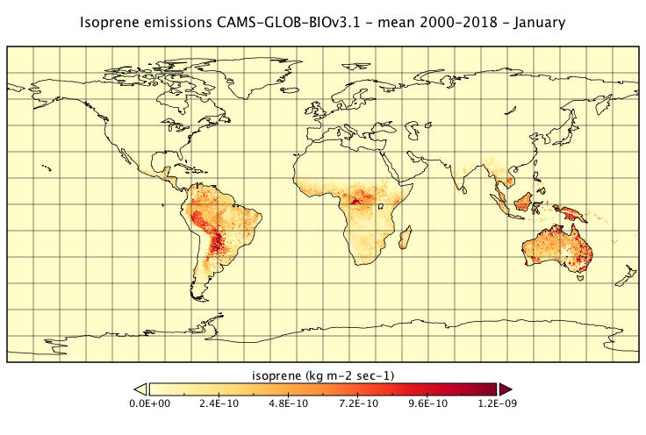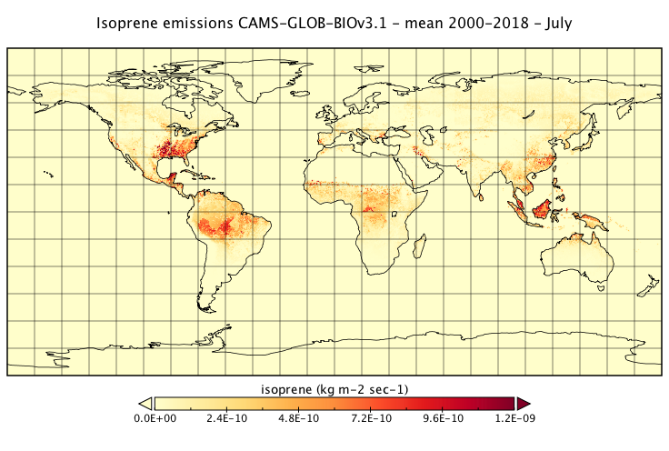
Fig. 7.1. Spatial distribution of isoprene monthly mean emissions in January and July in the CAMS-GLOB-BIOv3.1 dataset.

On a regional scale, there is a significant change in CAMS-GLOB-BIOv3.1 dataset for isoprene emissions in Europe. These emission estimates were calculated with an updated emission potential map based on species-specific vegetation data with high spatial resolution and emission factors information as implemented in the EMEP model (provided by Met Norway). This update leads to a decrease of European isoprene emissions by ~35% (i.e., from 10 to 6.5 Tg/year in 2016) (Sindelarova et al., 2022).

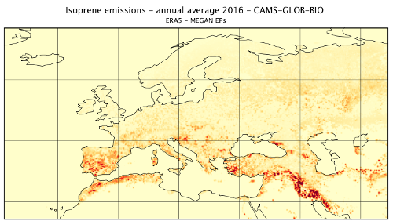
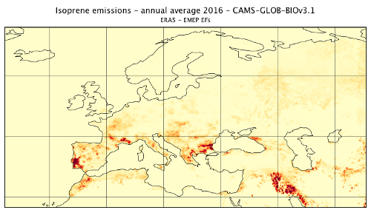
Fig. 7.2 shows a comparison of spatial distribution of annual mean isoprene emissions calculated with updated and MEGAN default emission potential maps. It can be seen that with MEGAN default EP maps, emissions are more homogeneously distributed over the whole domain, while with updated EP maps, emissions are concentrated at locations covered by high emitting species.


Fig. 7.2 Comparison of spatial distribution of isoprene annual mean emissions (year 2016) calculated with updated EP maps (left) and with MEGAN default EP maps (right).

The CAMS-GLOB-BIOv3.1 isoprene full time-series is presented in Fig 7.3. The top panel shows time evolution of the zonal means. The largest emission sources in the tropics are well visible, as well as additional sources in mid-northern latitudes.
The middle panel shows a time series of monthly global averages. For isoprene the seasonal cycle does not simply follow the summer seasons of northern and southern hemispheres. Isoprene emissions can be very localised to areas with high isoprene emitters, especially in the tropical band. If these locations get high temperatures and load of solar radiation, the increase in emission adds or even overcomes the expected isoprene emission in the hemisphere with summer season and smears out the seasonal cycle.
The bottom panels present the global annual totals for isoprene. The time series depicts the interannual variability of the emission budgets. The higher emission years usually correspond to El Niño events and the emission decreases with La Niña years.

Versions of the dataset

Currently, there are three versions of the CAMS-GLOB-BIO dataset that are publicly available from the Atmosphere Data Store.
- CAMS-GLOB-BIOv1.2 calculated with ERA-Interim meteorology (spatial resolution 0.5° x 0.5° for period of January 2000 - July 2019);
- CAMS-GLOB-BIOv3.0 calculated with ERA5 meteorology and annually changing land cover from ESA-CCI (spatial resolution of 0.25° x 0.25° for period of 2000-2019);
- CAMS-GLOB-BIOv3.1 calculated with ERA5 meteorology, static land cover and updated isoprene emission factors in Europe spatial resolution of 0.25° x 0.25° for period of 2000-2022).

The users are advised to use a dataset which is calculated with the same meteorology as they use in their simulations. If this does not apply, we recommend using the latest CAMS-GLOB-BIOv3.1 dataset. CAMS-GLOB-BIOv3.0 should be used for studies focusing on land cover change.

Earlier versions of the dataset are briefly described in Annex 1.

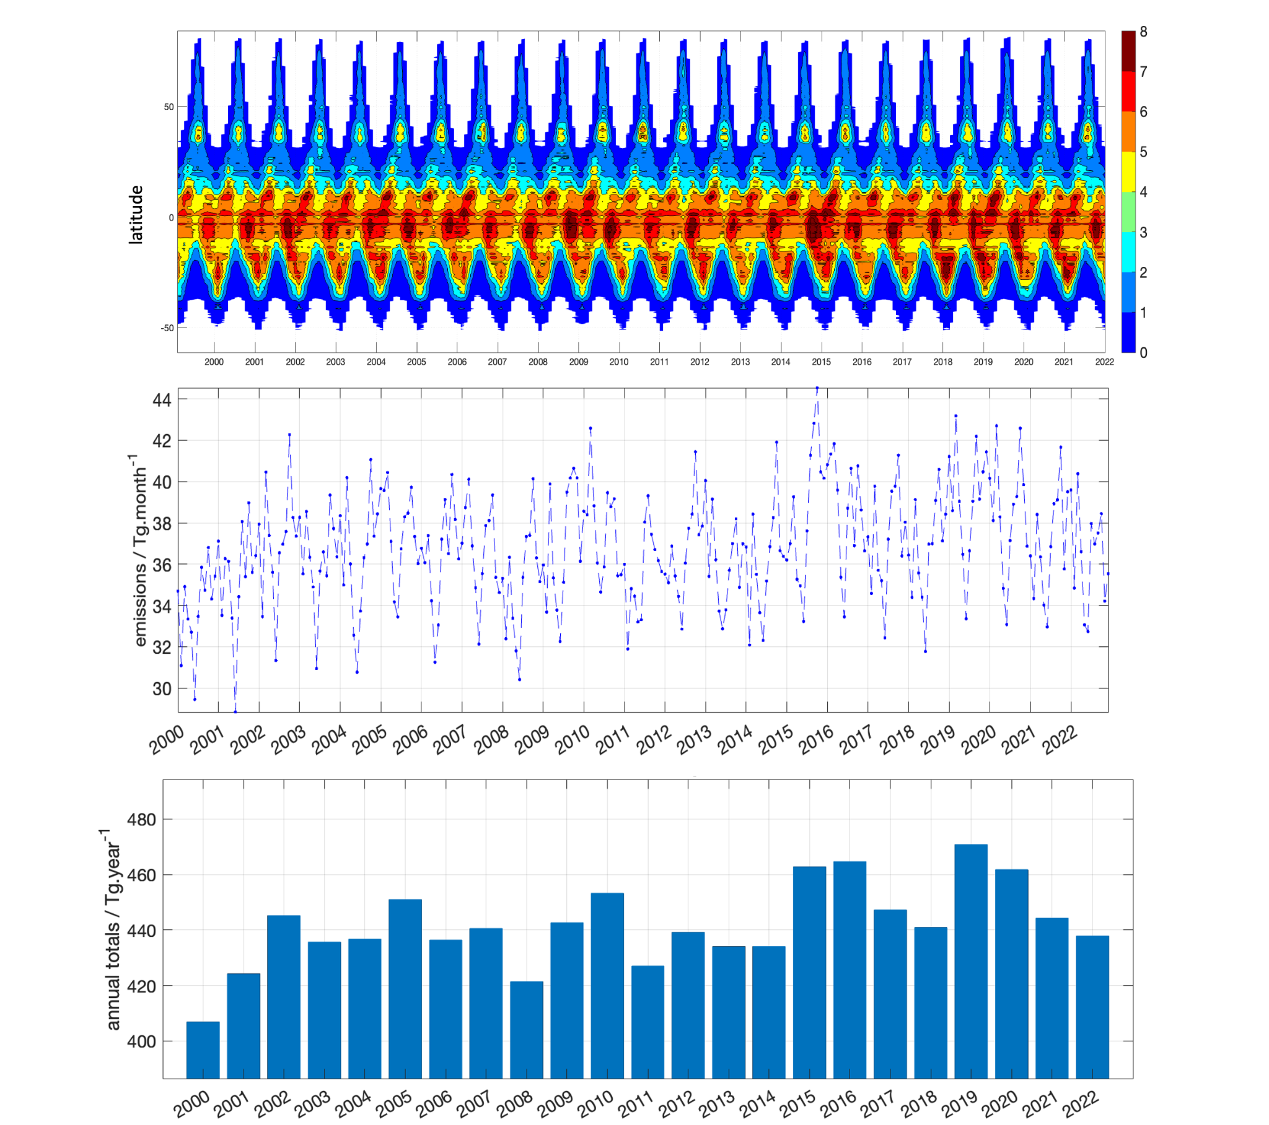
Fig. 7.3 Zonal averages of monthly mean isoprene emissions (mg m⁻² day⁻¹) (top), global monthly total isoprene emissions (Tg month⁻¹) (middle) and global annual total isoprene emissions (Tg yr⁻¹) (bottom) from the CAMS-GLOB-BIOv3.1 dataset.

References

ERA5: Copernicus Climate Change Service (C3S) (2017): ERA5: Fifth generation of ECMWF atmospheric reanalyses of the global climate. Copernicus Climate Change Service Climate Data Store (CDS), site accessed 13/01/2021. https://cds.climate.copernicus.eu/cdsapp#!/home; dataset reference: Hersbach, H., Bell, B., Berrisford, P., Biavati, G., Horányi, A., Muñoz Sabater, J., Nicolas, J., Peubey, C., Radu, R., Rozum, I., Schepers, D., Simmons, A., Soci, C., Dee, D., Thépaut, J-N. (2019): ERA5 monthly averaged data on pressure levels from 1979 to present. Copernicus Climate Change Service (C3S) Climate Data Store (CDS). (Accessed on 13-01-2021), 10.24381/cds.6860a573
ESA. Land Cover CCI Product User Guide Version 2. Tech. Rep. (2017). Available at: maps.elie.ucl.ac.be/CCI/viewer/download/ESACCI-LC-Ph2-PUGv2_2.0.pdf
Guenther A.B., Jiang X., Heald C. L., Sakulyanontvittaya T., Duhl T., Emmons L. K., and Wang X.: The Model of Emissions of Gases and Aerosols from Nature version 2.1 (MEGAN2.1): an extended and updated framework for modeling biogenic emissions, Geoscientific Model Development, 5, 1471-1492, doi:10.5194/gmd-5-1471-2012, 2012
Lawrence, P. J. and Chase, T. N.: Representing a new MODIS consistent land surface in the Community Land Model (CLM 3.0), J. Geophys. Res. Biogeo., 112, G01023, doi:10.1029/2006JG000168, 2007.
Poulter, B., MacBean, N., Hartley, A., Khlystova, I., Arino, O., Betts, R., Bontemps, S., Boettcher, M., Brockmann C., Defourny, P., Hagemann, S., Herold, M., Kirches, G., Lamarche, C., Lederer, D., Ottlé, C., Peters, M., and Peylin, P.: Plant functional type classification for earth system models: results from the European Space Agency's Land Cover Climate Change Initiative, Geosci. Model Dev., 8, 2315–2328, https://doi.org/10.5194/gmd-8-2315-2015, 2015.
Sindelarova, K., Markova, J., Simpson, D., Huszar, P., Karlicky, J., Darras, S., and Granier, C.: High resolution biogenic global emission inventory for the time period 2000–2019 for air quality modelling, Earth Syst. Sci. Data, 14, 251–270, https://doi.org/10.5194/essd-14-251-2022, 2022.
Yuan, H., Dai, Y., Xiao, Z., Ji, D., and Shangguan,W.: Reprocessing the MODIS Leaf Area Index products for land surface and climate modelling, Remote Sens. Environ., 115, 1171–1187, 2011.

The CAMS termite emissions: CAMS-GLOB-TERM

Authors: Jana Markova, Katerina Sindelarova

Methodology

Emissions of CH₄ from termite nests were estimated based on the methodology by Sanderson (1996). 11 ecosystems from the Olson vegetation database (Olson, 1989) were identified as termite habitats. As stated in Wood and Sands (1978), termites have been found up to 45°N and 45°S. Ecosystems falling outside these latitudes have therefore been excluded.

Each of the habitats was assigned termite biomass per m² and CH₄ emission flux per g of termite and hour (Table 8.1). Due to the diversity in termite species among the continents, different fluxes were considered for the regions of North and South America and Australia (group A) and for Europe, Africa and Asia (group B). Two of the habitats were also differentiated by humidity. Totals were then calculated from the CH₄ flux per m² and these values were assumed to represent the annual total CH₄ emission per grid cell.

Habitat | Termite biomass [g/m²] | CH₄ flux [g CH₄/g/h]
 |  | group A | group B
Rain Green Forest | 8 | 5.64 | 6.16
Tropical Rain Forest | 11 | 5.64 | 6.16
Montane/Seasonal Forest | 11.26 | 5.64 | 6.16
Temperate Forest | 3 | 1.77 | 1.77
Savanna, Hot Grass - arid | 0.96 | 2.9 | 7.6
Savanna, Hot Grass - nonarid | 10.6 | 3.2 | 7
Succulent/Thorn - arid | 0.98 | 2.9 | 7.6
Succulent/Thorn - nonarid | 8.43 | 3.2 | 7
Farmland | 5.38 | 3 | 3.9
Crops | 2.25 | 3 | 3.9
Temperate Grass | 5.2 | 1.77 | 1.77
Mediterranean, Eucalyptus, Acacia | 5.3 | 4.13 | 4.13
Highland Scrub, Semidesert | 2.7 | 4.13 | 4.13
Table 8.1. Termite habitats and their respective biomass and CH₄ fluxes

Jamali et al. (2011a) have found that CH₄ emissions from termite nests vary throughout the year due to seasonal changes in termite biomass and behaviour. These changes have mainly been correlated with moisture and temperature. We have used Global Precipitation Climatology Centre (GPCC; Schneider et al., 2011) precipitation data (long-term monthly means) to identify arid/nonarid regions and to introduce seasonality. Regions receiving less than 500 mm of precipitation per year were considered arid.

Seasonality was based on the study by Jamali et al. (2013) who measured and estimated monthly CH₄ fluxes from termites for a whole year. Monthly precipitation totals and temperature averages were fit with a linear regression model against the measurements made by Jamali et al. (2013) at Howard Springs, Australia (12.25°S, 131.25°E). Temperature was not statistically significant in the regression model and, therefore, the final model was based only on the precipitation data with a fit of R-squared 0.62. The annual emissions were distributed among the months of the year by the regression coefficients.

According to Anderson et al. (2010), Martius et al. (1996) and Kirschke et al. (2013), CH₄ emissions from termite nests do not significantly vary inter-annually and therefore our results are assumed to be representative for the whole period of 2000 - 2017, considered in the CAMS81 project.

Emissions data

The termite emissions dataset is gridded with a horizontal resolution of 0.5° x 0.5°. The emissions are given as monthly averages. The annual global emissions amount to 20.03 Tg(CH₄)/year, monthly totals are shown in Table 8.2.

Jan | Feb | Mar | Apr | May | Jun | Jul | Aug | Sep | Oct | Nov | Dec
1.75 | 1.67 | 1.8 | 1.64 | 1.59 | 1.57 | 1.78 | 1.84 | 1.63 | 1.56 | 1.53 | 1.67
Table 8.2. CH₄ emissions from termite nests - monthly global totals [Tg(CH₄)/month]

Most of the emissions are concentrated in the tropical regions within 15°N and 15°S with tropical Africa being the dominant source (Figure 8.1).

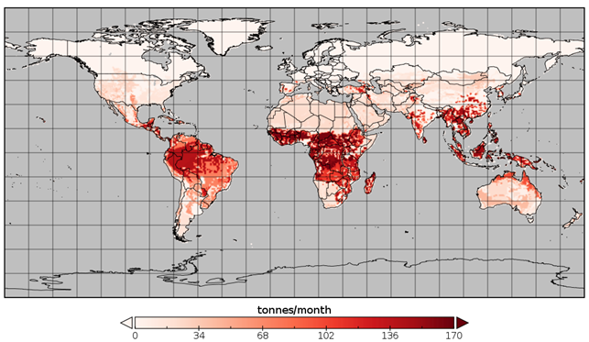
Figure 8.1: Spatial distribution of annual mean CH4 emissions from termites.

It is necessary to note that the estimate of the CH₄ emissions from termite nests is based on data and information with a very high level of uncertainty. The uncertainties originate mainly in the estimates of the representative termite biomass and CH₄ fluxes. These values were approximated by Sanderson (1996) from field measurements which may not be representative for all present termite species. Also, Jamali et al. (2011b) reported a significant diurnal variation of CH₄ flux for several termite species. Flux measurements made at a single time during the day may lead to underestimated or overestimated values of the representative flux.

The emissions from termite nests however represent a relatively minor source from the global total CH₄ budget. According to Saunois et al. (2016), the total global emissions of CH₄ range from 540 to 884 Tg(CH₄)/yr. The total of 20.03 Tg(CH₄)/yr therefore represents only about 3 % of the global CH₄ emissions.

Versions of the dataset

The current version of the global methane emissions from termites is called CAMS-GLOB-TERM_V1.1.

References

Anderson, B., Bartlett, K., Frolking, S., Hayhoe, K., Jenkins, J. and Salas, W., Methane and Nitrous Oxide Emissions from Natural Sources, Office of Atmospheric Programs, US EPA, EPA 430-R-10-001, Washington DC, 2010.

Jamali, H., Livesley, S. J., Dawes, T. Z., Hutley, L. B., Arndt, S. K., 2011a: Termite mound emissions of CH 4 and CO 2 are primarily determined by seasonal changes in termite biomass and behaviour. Oecologia (2011) 167:525–534, DOI 10.1007/s00442-011-1991-3.

Jamali, H., Livesley, S. J., Dawes, T. Z., Cook, G. D., Hutley, L. B., Arndt, S. K., 2011b: Diurnal and seasonal variations in CH₄ flux from termite mounds in tropical savannas of the Northern Territory, Australia. Agricultural and Forest Meteorology 151 (2011b), 1471-1479.

Jamali, H., Livesley, S. J., Grover, S. P., Dawes, T. Z., Hutley, L. B., Cook, G. D., Arndt, S. K., The Importance of Termites to the CH₄ Balance of a Tropical Savanna Woodland of Northern Australia. Ecosystems. DOI: 10.1007/s10021-011-9439-5, 2013.

Kirschke, S., et al., Three decades of global methane sources and sinks, Nat. Geosci., 6, 813–823, doi:10.1038/ngeo1955, 2013.

Martius, C., Fearnside, P.M., Bandeira, A.G., Wassman, R., Deforestation and methane release from termites in Amazonia, Chemosphere, 33, No. 3, p. 517-536, 1996.

Olson, J. S., Stanley, L., Colby, J., Ohrenschall, M., Olson World Ecosystems (WE1.4), NOAA/NGDC/WDC-A, Nat. Geophys. Data Cent., Boulder, Colorado, 1989.

Sanderson, M. G., 1996: Biomass of termites and their emission of methane and carbon dioxide: A global database. Global Biochemical Cycles, Vol. 10, No. 4, Pages 543-557, December 1996.

Saunois, M., Bousquet, P., Poulter, B., Ciais, P. et al., The global methane budget 2000–2012. Earth Syst. Sci. Data 8, 697–751, 2016.

Schneider, U., Becker, A., Finger, P., Meyer-Christoffer, A., Rudolf, B., Ziese, M., GPCC Full Data Reanalysis Version 6.0 at 0.5°: Monthly Land-Surface Precipitation from Rain-Gauges built on GTS-based and Historic Data. DOI: 10.5676/DWD_GPCC/FD_M_V7_050, 2011.

Wood, T. G., and Sands, W. A., The role of termites in ecosystems. Production Ecology of Ants and termites, edited by M. V. Brian, pp. 245-292, Cambridge Univ. Press, New York, 1978.

The CAMS soil emissions: CAMS-GLOB-SOIL

Authors: David Simpson, Anna Benedictow and Sabine Darras

Summary

This chapter describes v2.4 of the CAMS emission dataset of soil NO emissions (CAMSGLOB-SOIL v2.4). This updates versions 1.1 of these emissions which were provided in deliverable D81.3.6.1 in 2018, v2.1 that was delivered in D81.3.8.2 in August 2020, v2.2 that was delivered in March 2021 and v2.3 from March 2022. Updates since v1.1 have included new land-cover data, implementation of canopy reduction factors, changes in the temperature calculation and treatment of rainforest, see Table 9.1. Here we summarise the latest (v2.4) methodology and provide an overview of the results.
Data are provided globally at 0.5° x 0.5° degrees horizontal resolution, and with monthly time resolution over the period 2000-2020. Emissions are provided as total values and also with separate data for soil NO emissions induced by fertilizers/manure, atmospheric deposition, and pulsing, so that users can provide their own modifications if wanted.
This dataset is referred to as CAMS-GLOB-SOIL v2.4, with final calculations made in November 2022.
Table 9.1: Frequently used abbreviations and dataset versions
SL11 | Steinkamp and Lawrence (2011)
YL95 | Yienger and Levy (1995)
v1.1 | CAMS-GLOB-SOIL v1.1, 2018 version of soil NO emissions, giving above-soil emissions. See Simpson (2018), Granier et al. (2019)
v2.1 | CAMS-GLOB-SOIL v2.1, delivered August 2020. Updates included new land-cover data, implementation of canopy-reduction factors, changes in the temperature calculation and treatment of rainforest.
v2.2 | Last dataset of CAMS81, delivered March 2021. Various bug-fixes, application of growing seasons for crop emissions, and reduction in percentage of N-inputs released as NO (from 1% to 0.7%). See Simpson & Darras (2021).
v2.3 | v2.3 fixed issues with the biome emissions of v2.2 being kept constant across all years, errors in 2008-2010 meteorology, and uses updated CEDS inputs (sec. 9.2.3).
v2.4 | CAMS2_61 first update, delivered Dec. 2022. Uses ERA-5 meteorology and extends dataset (now 2000- 2020).

Methodology

The basic methodology is similar to that used in version 1.1 of CAMS-GLOB-SOIL (Simpson, 2018, hereafter v1.1, see also Table 9.1), and merges methods from Yienger and Levy (1995) (hereafter YL95), with various updates to reflect recent literature (especially Steinkamp and Lawrence, 2011, hereafter SL11) and availability of data. In all dataset versions, emissions are parameterized as a function of biome type, temperature and precipitation.

The basic emissions algorithm is given by:
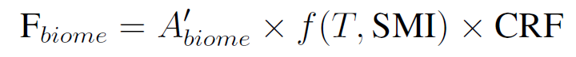 | (9.1)
where F_{biome} is the soil NOx flux (ng(N) m⁻² s⁻¹), A’_{biome} is a function of the biome-type, f(T,SMI) is a function of temperature (T) and soil moisture index (SMI), and CRF is the canopy reduction factor accounting for NOx-capture by the vegetation canopy above the soil. In YL95 A’_{biome} values were modified by estimates of locally available nitrogen (N_{avail}), which consists mainly of agricultural inputs of N (N from fertilizer, manure, hereafter N_{fert}), or atmospheric deposition of reactive nitrogen (hereafter N_{dep}), and a pulse factor, F_{pulse}. For this work we prefer to calculate the contributions of N_{fert}, N_{dep} and F_{pulse} separately, so we have:
(9.2)
In all versions, monthly resolution is provided. One important reason is that many of the underlying datasets have monthly resolution, and even this has substantial uncertainties. Secondly, the most dramatic short-term variation with soil NO emissions is associated with pulses, and for reasons given in Sect. 9.2.5, estimation of the timing of such events cannot reliably be provided at this stage.
The calculations of F_{biome}, F_{Nfert}, F_{Ndep} and F_{pulse} are summarised in Sects. 9.2.2–9.2.5 below. Canopy-reduction factors (CRF) are discussed in Sect. 9.2.6. Issues associated with rainforests and estimation of soil temperatures are discussed in Sects. 9.2.7–9.2.8.

Landcover

As of v2.1, we have made use of a MODIS-based landcover, which corresponds closely to the landcover used by SL11 in their analysis of emission factors. The data used were the MCD12C1v006 data set (Sulla-Menashe and Friedl, 2018; Friedl and Sulla-Menashe, 2015), downloaded from https://lpdaac.usgs.gov/products/mcd12c1v006/#tools. Of the available data sets, we used the LC Type 1 data, which give sub-pixel fractions of landcover classified according to the International Geosphere-Biosphere Programme (IGBP) system.
This MCD12C1 data set provided 17 basic land-cover types. These were further disaggregated into the 23 categories of SL11 by overlapping these data with the Köppen-Geiger climate classification as provided by Kottek et al. (2006). This new landcover map allows direct application of the SL11 emission factors as detailed in Sect. 9.2.2 below. The resulting 23 land-cover biomes are given in Table 9.2.

Calculation of F_{biome}

The biome emissions, F_{biome}, are driven by the underlying land-cover data, biome factors (A_{biome}), and meteorological drivers. Following YL95 and SL11, biome factors are given for dry and wet soils, with different temperature functions (f(T)) used for both. With the updated landcover used in v2.1 onwards, values of the emission factors were now taken directly from SL11, as tabulated in Table 9.2.
In v1.1–v2.3, meteorological data were from the ECMWF IFS model, as processed for the EMEP MSC-W model (Simpson et al., 2012), with soil temperature approximated from air temperatures. As of v2.4, the ECMWF ERA5 product was used, enabling direct use of soil temperatures. These data had 3-hourly time resolution, and a 0.5° x 0.5° degree longitude-latitude grid. As well as temperature, the most important meteorological input is the ‘soil moisture index’ (SMI) as used in EMEP, which is derived as:

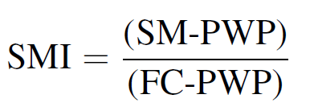 | (9.3)
where SM is volumetric soil moisture, PWP is the permanent wilting point, and FC is the field capacity, all in m³ m⁻³. SMI can be calculated in this way for each soil type in the grid, and then averaged to get a grid-average value which is more physically meaningful than a simple average over absolute volumetric soil moisture values. The SMI values used here from the upper 7 cm of the soil.
As seen from Table 9.2, we need to distinguish ‘dry’ from ‘wet’ soils. As explained in Simpson (2018) and Simpson and Darras (2021), we define soils with SMI>0.5 as wet, otherwise dry, which seems to give a similar frequency of wet soils to those found by SL11.

Calculation of F_{Nfert}

We assume that 0.7% of N-inputs from fertilizers and manures are released as NO. The estimation of these inputs and emissions in v2.4 makes use of global maps of global fertilizer and manure inputs from Potter et al. (2010, 2011) and scaling factors to get year-to-year variations from the CEDS database (Hoesly et al., 2018, McDuffie et al., 2020). (Data from the ECLIPSEv5a database for global NH₃ emission [www.iiasa.ac.at/web/home/research/ researchPrograms/air/ECLIPSEv5a.html] were used to link grid cells to country codes. The McDuffie et al CEDS data used were only available to 2019, so these emissions were assumed constant for the year 2020.

Calculation of F_{Ndep}

As with F_{Nfert} we assume that 0.7% of N-inputs from N-inputs are released as NO. The estimation of deposition-induced emissions makes use of data from the EMEP MSC-W chemical transport model (Simpson et al., 2012, 2014), but updated global model calculations from 2000-2020 were used - from the AMAP project (Whaley et al., 2022), and using ECLIPSEv6a emissions. Given the large uncertainties in N-deposition estimates (e.g. Simpson et al., 2014) and relatively small contribution of the F_{Ndep} term, this approach seemed acceptable for the current soil emissions calculation.

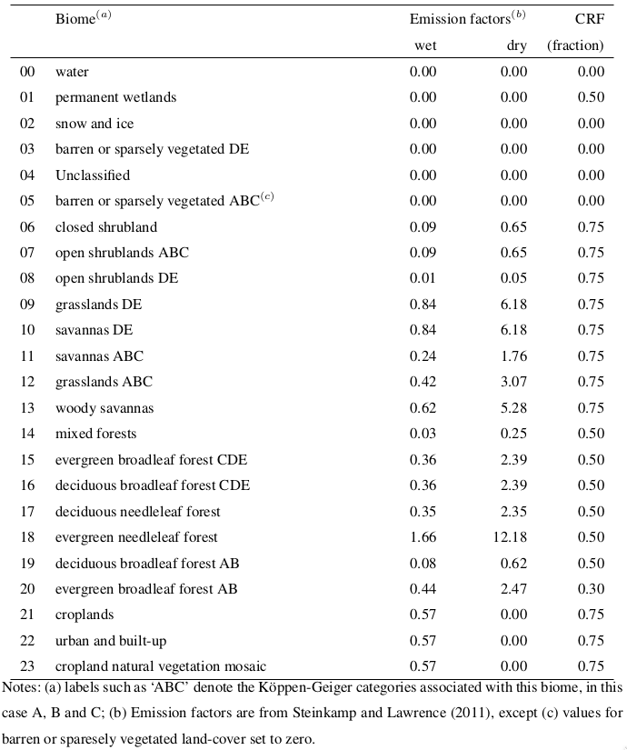
Table 9.2: Biome-based emission factors (ng(N) m⁻²s⁻¹) for dry and wet conditions, and canopy reduction factors (CRF), used for the MODIS/SL11 biomes.

Calculation of F_{pulse}

Although many studies suggest that pulsing is important, and can in principle be calculated using precipitation (YL95) or soil water changes (e.g. Hudman et al., 2012), there is little evidence that such pulses can be accurately timed or quantified in global or European scale CTMs. Indeed, Yan et al. (2005) noted that large scale NWP models have trouble predicting the conditions needed for pulsing, commenting that the ECMWF model’s data never reached a value low enough to trigger a pulse in tropical savanna regions. Tests conducted for v1.1 showed that the timing of pulses varies greatly from one method to another (e.g. precipitation or SMI-based, and for different definitions of ‘dry’ versus ‘wet’), so for v1.1 the pulsing emissions were omitted.
Given the obvious difficulties, a very pragmatic methodology was devised for F_{pulse} in v2.2 onwards. The occurrence of potential pulse events was counted using (i) a 14-day rainfall criteria (dry days were days with less than 1 mm rain per day, as long as SMI remained below 0.5), or (ii) changes in SMI of 0.01 after 3 days of SMI < 0.5 were counted. These criteria in themselves often suggested quite different monthly distributions of possible pulsing events. Instead of choosing, both counts were simply summed, smoothed in time, and used as a normalising factor for the pulsing emissions. Finally, the magnitude of annual emission was simply set to be 15% of the biome emissions set in Sect. 9.2.2, loosely consistent with estimates by SL11.
Further work will be needed, for example based upon use of satellite soil moisture data and/or comparison to TROPOMI NO₂ data, to find an algorithm which could be used with some confidence with regard to pulsing.

Calculation of CRF

It is well established that some of the NO emitted from soils can react quickly with ozone, forming NO₂. Some of this NO₂ is deposited within the canopy, reducing the emission of reactive N. YL95 used canopy reduction factors (CRFs) of between 0.25 for rain forests to 0.77 for Tundra, giving a global average of 0.53. These CRFs are very uncertain however, with Yan et al. (2005) estimating 0.67 and Hudman et al. (2012) suggesting 0.84. The CRF values used in this study, loosely based upon YL95 and Yan et al. (2005), are given in Table 9.2.

Tropical rainforests

The new land-cover data contains the category ‘evergreen broadleaf forest’ in Koppen-Geiger¨ climates A&B, which was identified as ‘rainforest’ in SL11. As suggested by YL95, Steinkamp et al. (2009) and SL11, this tropical rainforest category receives special treatment, in that the temperature functions are not applied, and instead dry/wet emissions are a function of season and not meteorology. Combined with the low CRF applies to rainforest the v2.2-v2.4 emissions are then significantly reduced compared to v1.1 estimates. (We can note however that YL95 and SL11 differed greatly in the emission factors suggested for rain forests: YL95 suggested 8.6 and 2.6 ng(N) m⁻²s⁻¹ for dry and wet soils respectively, whereas SL11 suggest just 2.47 and 0.44 ng(N) m⁻²s⁻¹ ).

Temperatures

In v1.1, soil temperatures (Ts) were estimated from air temperatures (Ta) using simple empirical relationships, but some issues were found with the equations used. In v2.1–v2.3 we made the very simple assumption that Ts = Ta. In v2.4 we have used the upper (7cm) soil temperature from the ERA5 meteorology. (Comparison of the use of Ta vs. Ts shows surprisingly little impact, however; usually emissions are within a few % with the two approaches.)

Results

Figure 9.1 illustrates the calculated soil NO emissions for the year 2010, giving total emissions and the three contributions from F_{biome} (which here includes F_{pulse}), F_{Nfert} and F_{Ndep}. Timeseries results for selected world regions are given in Fig. 9.2, covering the years 2000–2020. These plots illustrate the strong spatial variations in soil NO emissions, and also that the drivers vary markedly from region to region. For example, western European emissions are estimated to be strongly affected by the fertilizer-induced emissions, whereas in southern Africa or South America it is the biome component that strongly dominates. Atmospheric deposition is seen to be a relatively small contributor, but of course the relative contribution will increase away from agricultural source areas. Overall, year-to-year variations are not especially large, and trends are rather small.

Month to month variations in emissions are much more prominent, as illustrated in Fig. 9.3. Seasonal cycles are driven largely by temperature and associated wet/dry changes. The large contribution of F_{Nfert} to Western European emissions is also very evident, with largest F_{Nfert} emissions near the start of the growing season.

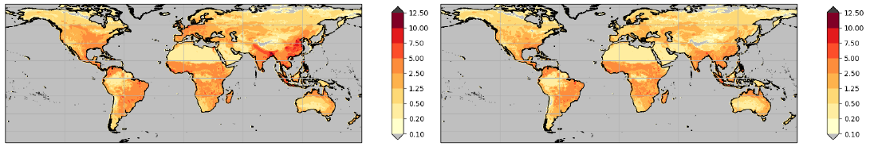
(a) Total, F_{soil} (b) Biome, F_{biome} + F_{pulse}

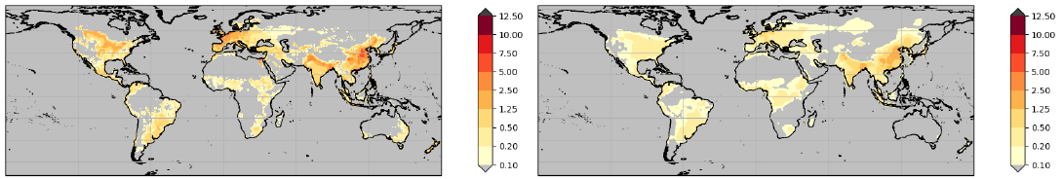
(c) Fert, F_{Nfert} (d) N-dep., F_{Ndep}

Figure 9.1: Above canopy NO emissions (ng(N) m⁻²s⁻¹) calculated for year 2010: (a) Total emissions (b) Biome emissions (eqn 9.1 + F_{pulse}) (c) Fertilizer-induced emissions (eqn 9.2) (d) Deposition-induced emissions (eqn 9.2).

Evaluation and follow-up

Table 9.3 compares our estimates with other values from the literature. A valuable new data set in this regard is that of Weng et al. (2020), who used the HEMCO model (Keller et al., 2014) to calculate soil-NO emissions at 0.5◦ lat × 0.625◦ lon for 1980-2017 and 0.25◦ lat × 0.3125◦ lon for 2014-2017. The HEMCO algorithm is based upon the methods of Hudman et al. (2012), and is designed for use by models such as GEOS-Chem.
In general the global emissions fit rather well with literature values, including those of Weng et al. (2020). Estimates for Europe and southern Africa are almost identical. Estimates are within 13% for N. America. Version 2.4 estimates are higher than Weng et al by 60% for South America and 36% for East Asia. V2.4 estimates are lower than Weng by 65% for North Africa (though similar to Zaehle), and 46% for South Asia. The larger discrepancies for these regions probably reflects increasing difficulties with land-cover characteristics (e.g. savanna or sparsely vegetated areas) and with the increasing frequency and importance of dry conditions.
Estimation of soil NO emissions is notoriously uncertain, since the emissions are driven by under-soil processes (microbial activity, pH, nutrients) rather than the simple meteorological and air quality variables which CTMs deal with, and there are very few data which can be used to evaluate such estimates.

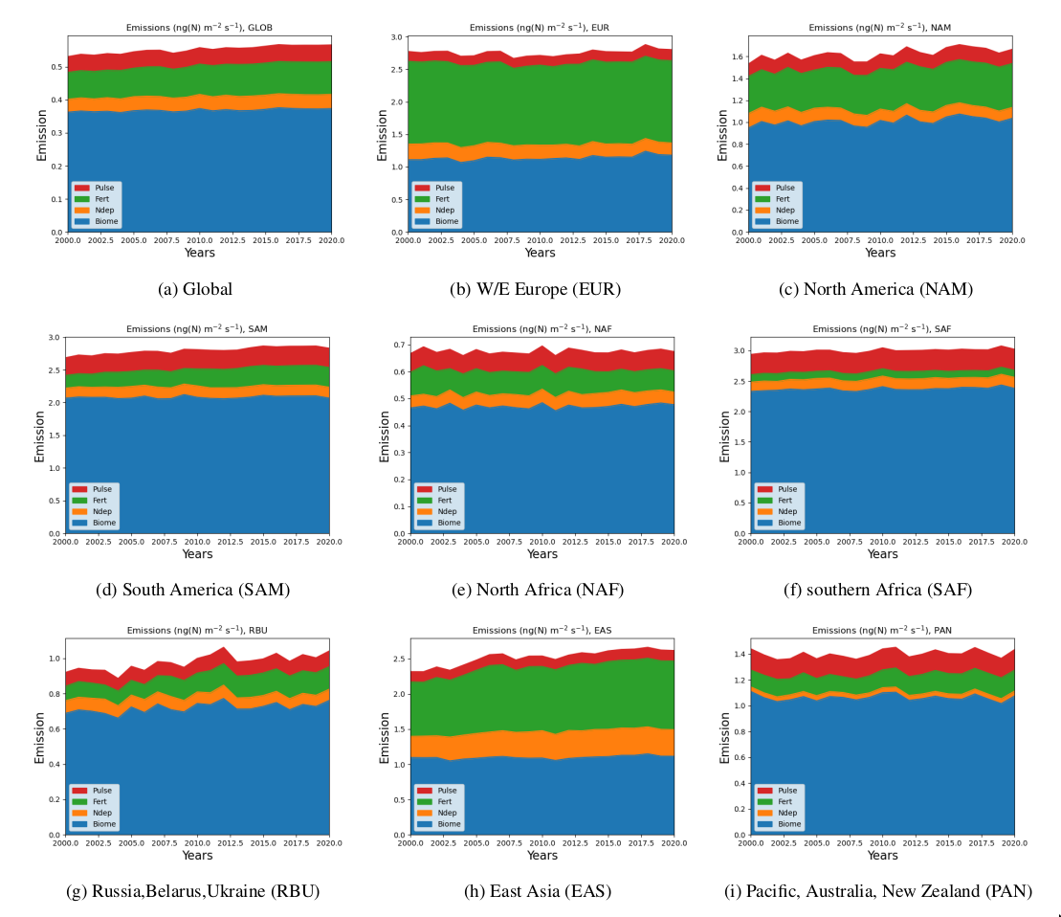
Figure 9.2: Above canopy NO emissions (ng(N) m⁻²s⁻¹) from v2.4, calculated for years 2000-2020 for selected world regions.
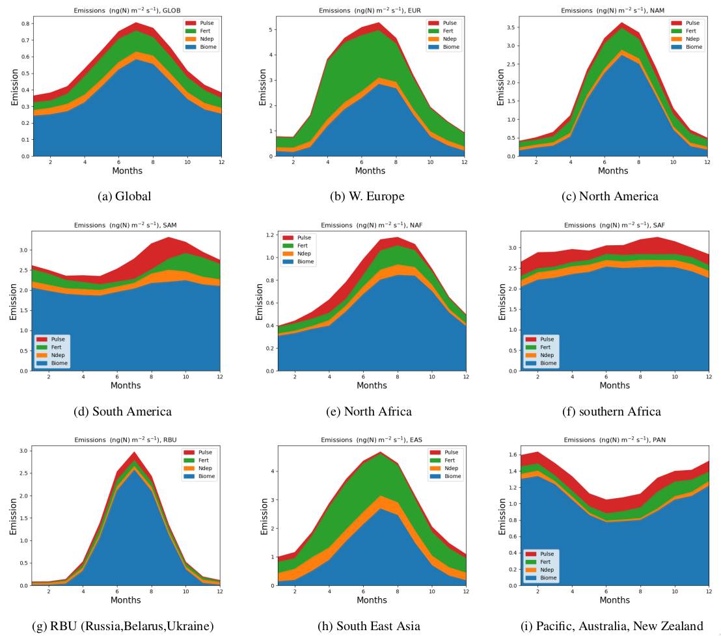

Figure 9.3: Above canopy NO emissions (ng(N) m⁻²s⁻¹) calculated for the year 2010 for selected world regions.

In all versions we have aimed at pragmatic solutions rather than sophistication, in order to set up a transparent initial framework, and to avoid over-parameterising a model in which many of the underlying datasets (e.g. on agricultural inputs, or soil characteristics) are necessarily uncertain. Emissions have been provided on a monthly basis over the 2000-2020 period, since there seemed to be no basis for making estimates at shorter time duration that could be shown to be reliable.

Future revisions to this dataset will hopefully include improved estimation of soil moisture and precipitation impacts, inclusion of the impact of forest-fires, and generally more use of field data and satellite products to evaluate and constrain the estimated emissions. More details of the v2.2 methodology (and largely applicable also to v2.4), along with results and a discussion of how to use these emissions with anthropogenic datasets (and how to avoid double-counting) are given in Simpson and Darras (2021).

Table 9.3: Emissions (above canopy) of soil NO (Tg(N)/yr).
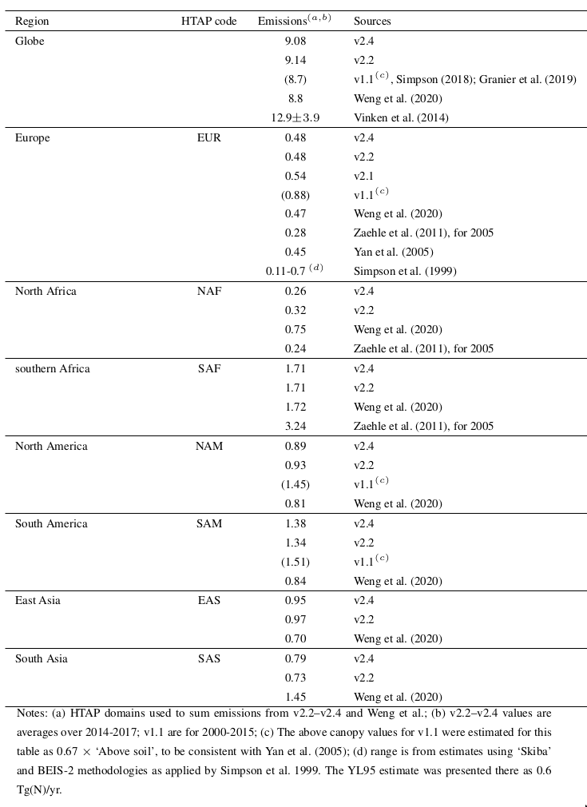

Versions of the dataset

The current version of the global soil NO emissions is called CAMS-GLOB-SOIL v2.4. Table 9.1 gives a brief overview of the earlier versions.

Earlier versions of the dataset are briefly described in Annex 1.

Acknowledgements

This work was also partly supported by EMEP under UN-ECE. The computations were partly performed on resources provided by UNINETT Sigma2 - the National Infrastructure for High Performance Computing and Data Storage in Norway (grant NN2890k and NS9005k). IT infrastructure in general was available through the Norwegian Meteorological Institute (MET Norway).

References

Friedl, M. and Sulla-Menashe, D.: [Data set] MCD12C1 MODIS/Terra+Aqua Land Cover Type Yearly L3 Global 0.05Deg CMG V006, https://doi.org/10.5067/MODIS/MCD12C1.006, distributed by NASA EOSDIS Land Processes DAAC, Last access 2020-08-27., 2015.

Granier, C., Darras, S., Denier van der Gon, H., Doubalova, J., Elguindi, N., Galle, B., Gauss, M., Guevara, M., Jalkanen, J.-P., Kuenen, J., Liousse, C., Quack, B., Simpson, D., and Sindelarova, K.: The Copernicus Atmosphere Monitoring Service global and regional emissions (April 2019 version), doi:10.24380/d0bn-kx16, https://atmosphere.copernicus.eu/sites/default/files/ 2019-06/cams_emissions_general_document_apr2019_v7.pdf, 2019.

Guenther, A. B., Jiang, X., Heald, C. L., Sakulyanontvittaya, T., Duhl, T., Emmons, L. K., and Wang, X.: The Model of Emissions of Gases and Aerosols from Nature version 2.1 (MEGAN2.1): an extended and updated framework for modeling biogenic emissions, Geoscientific Model Dev., 5, 1471–1492, doi: 10.5194/gmd-5-1471-2012, http://www.geosci-model-dev.net/5/1471/2012/, 2012.

Hoesly, R. M., Smith, S. J., Feng, L., Klimont, Z., Janssens-Maenhout, G., Pitkanen, T., Seibert, J. J., Vu, L., Andres, R. J., Bolt, R. M., Bond, T. C., Dawidowski, L., Kholod, N., Kurokawa, J.I., Li, M., Liu, L., Lu, Z., Moura, M. C. P., O’Rourke, P. R., and Zhang, Q.: Historical (1750– 2014) anthropogenic emissions of reactive gases and aerosols from the Community Emissions Data System (CEDS), Geoscientific Model Dev., 11, 369–408, doi:10.5194/gmd-11-369-2018, https://www.geosci-model-dev.net/11/369/2018/, 2018.

Hudman, R. C., Moore, N. E., Mebust, A. K., Martin, R. V., Russell, A. R., Valin, L. C., and Cohen, R. C.: Steps towards a mechanistic model of global soil nitric oxide emissions: implementation and space based-constraints, Atmos. Chem. Physics, 12, 7779–7795, doi:10.5194/acp-12-7779-2012, 2012.

Jaegle, L., Steinberger, L., Martin, R. V., and Chance, K.: Global partitioning of NOx sources using satellite observations: Relative roles of fossil fuel combustion, biomass burning and soil emissions, Faraday Discuss., 130, 407–423, doi:10.1039/B502128F, http://dx.doi.org/10.1039/B502128F, 2005.

Keller, C. A., Long, M. S., Yantosca, R. M., Da Silva, A. M., Pawson, S., and Jacob, D. J.: HEMCO v1.0: a versatile, ESMF-compliant component for calculating emissions in atmospheric models, Geoscientific Model Dev., 7, 1409–1417, doi:10.5194/gmd-7-1409-2014, 2014.

Kottek, M., Grieser, J., Beck, C., Rudolf, B., and Rubel, F.: World Map of the Köppen-Geiger climate classification updated, Meteorologische Zeitschrift, 15, 259–263, 2006.

Lawrence, D. M., Oleson, K. W., Flanner, M. G., Thornton, P. E., Swenson, S. C., Lawrence, P. J., Zeng, X., Yang, Z.-L., Levis, S., Sakaguchi, K., Bonan, G. B., and Slater, A. G.: Parameterization Improvements and Functional and Structural Advances in Version 4 of the Community Land Model, J. Adv. Modeling Earth Systems, 3, doi:10.1029/2011MS000045, 2011.

McDuffie, E. E., Smith, S. J., O'Rourke, P., Tibrewal, K., Venkataraman, C., Marais, E. A., Zheng, B., Crippa, M., Brauer, M. & Martin, R. V., A global anthropogenic emission inventory of atmospheric pollutants from sector- and fuel-specific sources (1970--2017): an application of the Community Emissions Data System (CEDS) Earth System Sci. Data., 12, 3413-3442, doi: 10.5194/essd-12-3413-2020, 2020.

Potter, P., Ramankutty, N., Bennett, E. M., and Donner, S. D.: Characterizing the Spatial Patterns of Global Fertilizer Application and Manure Production, Earth Interactions, 14, 1–22, doi: 10.1175/2009EI288.1, 2010.

Potter, P., Ramankutty, N., Bennett, E. M., and Donner, S. D.: Global Fertilizer and Manure, Version 1: Nitrogen Fertilizer Application, http://dx.doi.org/10.7927/H4Q81B0R, dataset, 2011.

Simpson, D.: D81.3.6.1, Soil N emissions for 2000-present, Deliverable report for CAMS-SOIL-NO v1.1 data, Ref: CAMS81 2017SC1 D81.3.6.1-201804 v1.docx, available in large part also as Chapter 9 of Granier et al., 2019: doi: 10.24380/d0bn-kx16, 2018.

Simpson, D. and Darras, S.: Global soil NO emissions for Atmospheric Chemical Transport Modelling: CAMS-GLOB-SOIL v2.2, Earth System Sci. Data., doi: 10.5194/essd-2021-221, 1-35, 2021.

Simpson, D., Winiwarter, W., Borjesson, G., Cinderby, S., Ferreiro, A., Guenther, A., Hewitt, C. N., Janson, R., Khalil, M. A. K., Owen, S., Pierce, T. E., Puxbaum, H., Shearer, M., Skiba, U., Steinbrecher, R., Tarrason, L., and Oquist, M. G.: Inventorying emissions from Nature in Europe, J. Geophys. Res., 104, 8113–8152, 1999.

Simpson, D., Benedictow, A., Berge, H., Bergstrom, R., Emberson, L. D., Fagerli, H., Flechard, C. R., Hayman, G. D., Gauss, M., Jonson, J. E., Jenkin, M. E., Nyiri, A., Richter, C., Semeena, V. S., Tsyro, S., Tuovinen, J.-P., Valdebenito, A., and Wind, P.: The EMEP MSC-W chemical transport model – technical description, Atmos. Chem. Physics, 12, 7825–7865, doi:10.5194/acp-12-7825-2012, http: //www.atmos-chem-phys.net/12/7825/2012/acp-12-7825-2012.html, 2012.

Simpson, D., Christensen, J., Engardt, M., Geels, C., Nyiri, A., Soares, J., Sofiev, M., Wind, P., and Langner, J.: Impacts of climate and emission changes on nitrogen deposition in Europe: a multimodel study, Atmos. Chem. Physics, 14, 6995–7017, doi:10.5194/acp-14-0073-2014, http://www. atmos-chem-phys.net/14/0073/2014/acp-14-0073-2014.html, 2014.

Steinkamp, J. and Lawrence, M. G.: Improvement and evaluation of simulated global biogenic soil NO emissions in an AC-GCM, Atmospheric Chemistry and Physics, 11, 6063–6082, doi:10.5194/ acp-11-6063-2011, http://www.atmos-chem-phys.net/11/6063/2011/, 2011.

Steinkamp, J., Ganzeveld, L. N., Wilcke, W., and Lawrence, M. G.: Influence of modelled soil biogenic NO emissions on related trace gases and the atmospheric oxidizing efficiency, Atmos. Chem. Physics, 9, 2663–2677, 2009.

Sulla-Menashe, D. and Friedl, M.: User guide to collection 6 MODIS Land Cover (MCD12Q1 andMCD12C1) Product, https://lpdaac.usgs.gov/documents/101/MCD12_User_ Guide_V6.pdf, 2018.

Vinken, G. C. M., Boersma, K. F., Maasakkers, J. D., Adon, M., and Martin, R. V.: Worldwide biogenic soil NOx emissions inferred from OMI NO2 observations, Atmospheric Chemistry and Physics, 14, 10363–10381, doi:10.5194/acp-14-10363-2014, https://www.atmos-chem-phys.net/14/ 10363/2014/, 2014.

Weng, H., Lin, J., Martin, R., Millet, D. B., Jaegl, A, L., Ridley, D., Keller, C., Li, C., Du, M., and Meng, J.: Global high-resolution emissions of soil NOx, sea salt aerosols, and biogenic volatile organic compounds, Scientific Data, 7, 148, doi:10.1038/s41597-020-0488-5, https://doi.org/10.1038/ s41597-020-0488-5, 2020.

Whaley, C.H., Mahmood, R., von Salzen, K., Winter, B., Eckhardt, S., Arnold, S., Beagley, S., Becagli, S., Chien, R.-Y., Christensen, J., Damani, S..M., Dong, X., Eleftheriadis, K., Evangeliou, N., Faluvegi, G., Flanner, M., Fu, J.S., Gauss, M. et al., Model evaluation of short-lived climate forcers for the Arctic Monitoring and Assessment Programme: a multi-species, multi-model study, Atmos. Chem. Phys., 22, 5775–5828, https://doi.org/10.5194/acp-22-5775-2022, 2022.

Williams, E., Guenther, A., and Fehsenfeld, F.: An inventory of nitric oxide emissions from soils in the United States, J. Geophys. Res., 97, 7511–7519, 1992.

Yan, X. Y., Ohara, T., and Akimoto, I.: Statistical modeling of global soil NOx emissions, Global Biogeochem. Cycles, 19, doi:10.1029/2004GB002276, 2005.

Yienger, J. and Levy, H.: Empirical model of global soil-biogenic NOx emissions, J. Geophys. Res., 100, 11447–11464, 1995.

The CAMS oceanic emissions: CAMS-GLOB-OCE

Authors: Michael Gauss, Dirk Olivié, Birgit Quack, Kirstin Krüger

Methodology

Emissions for dimethyl sulphide (DMS), volatile short-lived halogenated substances (VSLHS), and carbonyl sulphide (OCS) from the oceans are provided in the CAMS-GLOB-OCE dataset. Different methodologies have been used to derive the emissions for these three compounds. However, the common strategy has been to find best available data on their concentrations in ocean water, best available meteorological data, and then to use flux formulas based on Henry’s law to derive emission fluxes as a function of longitude, latitude and time. For DMS and VSLHS, concentration climatologies were combined with meteorological data from the ERA5 reanalysis (Hersbach et al., 2018) to create multi-year data sets of fluxes for CAMS-GLOB-OCE.
For OCS, the data set of Lennartz et al. (2017) was included in CAMS-GLOB-OCE essentially unchanged. Although concentrations climatologies have been combined recently with ERA5 reanalysis data also for OCS, that data set is described and published in Lennartz et al. (2021) and will not be described in detail here.
As the methods and input data for the various components in the CAMS-GLOB-OCE inventory differ slightly, they are described in independent sub-sections in the following.

DMS emissions

DMS concentrations in ocean water were provided on 1° x 1° spatial resolution by Lana et al. (2011). These data are derived from a large number of measurements performed during the 1980-2009 period and are accessible from a web page of the Surface Ocean Lower Atmosphere Study (SOLAS), see https://www.bodc.ac.uk/solas_integration/implementation_products/group1/dms/. The files are provided in csv (comma-separated values) format, one file per month, and in units of nmol(DMS)/L. The data are given as monthly means, averaged over the multi-year period covered by the measurements, and there is no inter-annual variability in the data. The concentrations are thus to be considered as average seasonal cycles representative of the 1989-2009 period.

The method applied below to calculate DMS emissions also requires sea surface temperature (or skin temperature) as well as the zonal and meridional components of surface wind speed as input. In the latest version of the CAMS-OCE-GLOB data set, these have been taken from the ERA5 reanalysis (more specifically: its product line called ‘ERA5 hourly data on single levels from 1979 to present’, Hersbach et al. (2018)) through the Copernicus Climate Change Service (C3S) (https://climate.copernicus.eu/). One file per year and parameter, containing hourly data on 0.25° x 0.25° resolution, was downloaded. For wind speed, the zonal and meridional components of wind speed at 10m altitude (u₁₀ and v₁₀, respectively) were downloaded separately and converted into total wind speed U according to

U = sqrt(u₁₀²+ v₁₀²) units: m/s

The formulas to calculate ocean-atmosphere fluxes are based on equations by Nightingale et al. (2000) and their implementation in the Norwegian Earth System model.

The emission (flux) of a gas from the ocean to the atmosphere can be calculated as F = k * ΔC, where k is the gas exchange coefficient and ΔC = CW - CWeq is the difference between the actual concentration (CW) and the equilibrium concentration (CWeq) of the gas in seawater. If the actual concentration is larger than the equilibrium concentration (which in turn depends on the concentration of the gas in the overlying atmosphere) there is emission from the ocean to the atmosphere, which we in our case define as positive. The equilibrium concentration CWeq can be expressed by Henry’s law, which states that the amount of dissolved gas in a liquid (here: the equilibrium concentration of DMS in seawater) is proportional to its partial pressure above the liquid:

CWeq = H * CA

where CA is the concentration of the gas in the atmosphere above the sea surface and H is Henry’s law constant. For DMS the concentration in the atmosphere CA is so small compared to its concentration in seawater that we can assume ΔC = CW, i.e.

F_{DMS} = k_{DMS} * CW_{DMS}

CW_{DMS} is taken from the Lana et al. (2011) climatology, while for k_{DMS} (the gas exchange coefficient for DMS) we proceed as follows:

The gas exchange coefficient k₆₀₀ (for CO₂ in freshwater at 20°C, sometimes also called piston velocity) is calculated as

k₆₀₀ = 0.222 * U² + 0.333 * U unit: cm/hour
where U is the total wind speed (in m/s) calculated above. The temperature-dependent Schmidt number SC for DMS is parameterized with the 4-degree formula of Wanninkhof (2014):
SC_{DMS} = 2855.7-177.63*T+6.0438*T^2-0.11645*T^3+0.00094743*T^4 unit: dimensionless
where T in our calculation is the skin temperature (given in °C) from the ERA5 reanalysis. This formula is valid between -2°C and +40°C. The gas exchange coefficient for DMS is calculated as
k_{DMS} = k₆₀₀ * sqrt(k₆₀₀/SC_{DMS}) unit: cm/hour
Finally, the flux of DMS is calculated as:
F_{DMS} = k_{DMS} *2.778e-15 *M_{DMS} *CW_{DMS} unit: kg(DMS)/m²/s
where M_{DMS} is the molecular weight of DMS (=62.13 g/mol) and CW_{DMS} is the concentration of DMS in seawater (given in nmol/L). The unit conversion factor 2.778e-15 is needed to obtain the flux F_{DMS} in units of kg(DMS)/m²/s (see explanation below).

Explanation of the unit conversion factor:
F_{DMS} (in kg(DMS)/m²/s)
= k_{DMS} (in cm/hr) * 2.778e-15 * 62.13 g/mol *C_{DMS} (in nmol/L)
= [k_{DMS}/100/3600] m/s * [62.13/1000] kg/mol *[C_{DMS}*1e-9/1e-3] mol/m³
→ Unit conversion factor: 1/100/3600 * 1/1000 * 1e-9/1e-3 = 2.778e-15
In the current version of the data set, the resulting fluxes are multiplied by ‘one minus the fraction of sea ice’. The fraction of sea ice is a number between 0 and 1 and represents the fraction of a grid cell that is covered by sea ice. In most grid cells, the fraction of sea ice is zero and the flux remains unchanged, but in polar regions the flux can be significantly reduced.

For CAMS-GLOB-OCE, daily means were calculated on a resolution of 0.5° x 0.5°. This relatively high resolution does not reflect the (partly limited) accuracy of some of the input data but exploits the relatively high spatial resolution of the meteorological data and thus keeps some of the high variability in wind speed, to which the gas exchange coefficient of DMS responds quite strongly.

Volatile short-lived halogenated substances
Volatile short-lived halogenated substances (VSLHS) in CAMS-OCE-GLOB are bromoform (CHBr₃), dibromomethane (CH₂Br₂), and methyl iodide (CH₃I). The gridded emission data are based on observed concentration data (in ocean water), ocean properties taken from the World Ocean Atlas (2013, 2018), flux formulas described in Ziska et al. (2013), with updates provided by Dr. B. Quack (2017, pers. comm.), and meteorological data from the ERA5 reanalysis (Hersbach, 2018). The method will be described in more detail below. Users of the data should, in addition to CAMS, make reference to the publication of Ziska et al. (2013) and the World Ocean Atlas (2013, 2018) and the ERA5 reanalysis (Hersbach, 2018).
VSLHS concentrations in the ocean were provided on 1° x 1° spatial resolution by Ziska et al. (2013). The data are derived from a large number of measurements, which were performed during the 1989-2011 period. The data are accessible as supplementary material to the paper of Ziska et al. (2013) (at https://www.atmos-chem-phys.net/13/8915/2013/acp-13-8915-2013-supplement.zip). This zip-archive contains the text file Objective_Mapping_and_Linear_Regression_Data.txt, with ocean and atmosphere concentrations of VSLHS, obtained through the Objective Mapping and the Ordinary Least Square (OLS) technique. Ocean concentrations are given in units of pmol/L while atmospheric concentrations are given in parts per trillion by volume (pptv). There is no seasonal or inter-annual variation in the file; hence the concentrations are to be considered as average values representative of the 1989-2011 period. For more details see Ziska et al. (2013).

The calculation of halocarbon fluxes also requires data on ocean temperature, salinity and density. Temperature and salinity can be obtained from the World Ocean Atlas 2018 (WOA, 2018) while density is available from the previous version, World Ocean Atlas 2013 (WOA, 2013). The data files, provided in netCDF format cover the period 1995 to 2012. The data are given as monthly means and are stored in two data sets: the first one is representative of the 1995-2004 period and features a spatial resolution of 1° x 1°, while the second one is representative of the 2005-2012 period and is given on 0.25° x 0.25° resolution. Temperature data are provided in degrees Celsius, density is given as sigma values (kg/m³ in excess of 1000 kg/m³), and salinity is given in practical salinity units (PSU, i.e. grams of salt per 1000 grams of sea water). For CAMS-GLOB-OCE, the surface layer values of the ‘objectively analyzed climatologies’ (objectively interpolated mean fields for oceanographic variables at standard depth levels for the World Ocean) were used.
The formulas to calculate ocean-atmosphere fluxes based on the input data described in the previous section were presented and explained by Ziska et al. (2013). Slightly updated versions were obtained from B. Quack at GEOMAR (2017, pers. comm.).
First, the diffusion coefficient D, here given in [cm²/s], is calculated for each VSLHS species (Quack and Wallace, 2003):
D_{CH3I} = 2.5e-9 * SST² + 2.199e-7 * SST + 5.2612e-6
D_{CH2Br2} = 2.23e-9 * SST² + 1.9699e-7 * SST + 4.71321e-6
D_{CHBr3} = 1.93e-9 * SST² + 1.686e-7 * SST + 4.0342e-6
where SST = Sea Surface Temperature in Kelvin [K] (in the current version of the emission data set we used the skin temperature from the ERA5 data instead (Hersbach et al., 2018)).
The kinematic viscosity ν can be calculated as (Siedler and Peters, 1986):
ν = { [ 0.001002 * 10^((1.1709*(20-SST)-0.001827*(SST-20)^2)/(SST+89.93)) ] * [1+(0.00010675
+0.00005185*SST) * (OWD*OWS/1806.55)^0.5+(0.002591+0.000033*SST) * OWD * OWS
/1806.55] } /OWD * 10000.
where SST is the sea surface temperature in °C, OWD is ocean water density in [kg/m³], and OWS is ocean water salinity in PSU. The two latter parameters have been taken from the World Ocean Atlas, while for SST we use ‘skin temperature’ from ERA5 in this version of the data set.
From the kinematic viscosity ν and the diffusion coefficients D_{i} we calculate the dimensionless Schmidt Number SN_{i} for each species i as:
SN_{i} = ν / D_{i} for i=CH₃I, CH₂Br₂, and CHBr₃
Having established the Schmidt number, and making use of the 10-meter wind speed U = sqrt (u₁₀²+v₁₀²) given in [m/s], we can now calculate the gas exchange coefficient k for each species (given in units of cm/hour) (Nightingale, 2000):
k_{i} = (0.222*U^2+0.333*U) * sqrt(600/SN_{i}) for i=CH₃I, CH₂Br₂, and CHBr₃
We furthermore need Henry’s Law constants, calculated from the sea surface temperature (°C) and empirically derived coefficients for each species (Moore et al., 1995):
H_{CH3I} = exp [-4338 / (SST+273.15) + 13.32]
H_{CH2Br2} = exp [-4418 / (SST+273.15) + 11.7]
H_{CHBr3} = exp [-4973 / (SST+273.15) + 13.16]
According to Henry solubility, the equilibrium concentration EqCw in sea water (given in [pmol(species)/L]) equals the air concentration Ca of the species divided by Henry’s law constant:
EqCw_{i} = Ca_{i} / H_{i} for i=CH₃I, CH₂Br₂, and CHBr₃
The flux across the sea-air interface is finally calculated as the product between the gas exchange coefficient k and the difference between the actual (measured) water concentration Cw_{i} (from Ziska et al., 2013) and the equilibrium water concentration EqCw_{i} (both given in [pmol(species)/L]):
F_{i}= k_{i} *(Cw_{i}- EqCw_{i})*10 for i=CH₃I, CH₂Br₂, and CHBr₃
(The unit conversion factor 10 is needed to obtain units of pmol(species)/m²/hour.)
In the current version of the data set, the resulting fluxes are multiplied by ‘one minus the fraction of sea ice’. The fraction of sea ice is a number between 0 and 1 and represents the fraction within each grid cell that is covered by sea ice. In most ocean pixels of the globe the fraction of sea ice is zero, so that the flux remains unchanged, but in polar regions it can be reduced quite significantly.
Before writing out to the data files, the fluxes are averaged over one day and divided by 3600 to obtain units of pmol(species)/m²/s. The sums in CAMS-GLOB-OCE were checked by multiplying fluxes with the areas of each grid cell, integrating over the globe, and comparing the totals with the numbers in Ziska et al. (2013).

OCS

The OCS emissions data set was compiled by S. Lennartz at GEOMAR (Helmholtz Centre for Ocean Research Kiel / Germany). It was provided to CAMS_81 in 2017 (S. Lennartz, pers. comm.) as a netCDF file containing OCS emissions on 2.8° x 2.8° resolution (64 latitude bins and 128 latitude bins) in units of [g(S) m⁻² month⁻¹]. Details on the data set are given in the publication of Lennartz et al. (2017) and supplementary material.

Lennartz et al. (2017) collected measurement data for the 2002 to 2014 period to create maps of OCS concentrations and used meteorological data from the ERA-Interim data set to calculate emission fluxes of direct and indirect sea-air fluxes of OCS. The original data file provided by S. Lennartz is called ‘lennartz2017_ACP_OCSDMSCS2.nc’ and contains direct emissions of OCS, but also indirect emissions in the form of short-lived DMS and CS₂ which are quickly oxidized into OCS.
For CAMS-GLOB-OCE the data contained in the netCDF file ‘lennartz2017_ACP_OCSDMSCS2.nc’ (provided as supplementary material to Lennartz et al. (2017)) have been regridded to 1° x 1° resolution, but without adding any fine-scale information. In addition to the regridding, the time dimension was modified and the field was translated by 180 degrees and flipped North-South, in order to get a similar format as the other components in the CAMS-GLOB-OCE inventory.

Emissions data

DMS
Averaged over the 2000-2019 period, the annual global emissions of DMS in CAMS-GLOB-OCE version 3.1 amount to 25.7 Tg(S)/yr, which is near the lower end but still within the uncertainty range of 24.1 to 40.4 Tg(S)/yr estimated by Lana et al. (2011). The emissions display a significant seasonal variation, with largest emissions during the summer season. Emissions are larger in the Southern Hemisphere than in the Northern Hemisphere.
Each of the DMS files in CAMS-GLOB-OCE contains longitude values, latitude values, and the emissions from ocean water in units of kg(DMS)/m²/s. In grid cells with no available data or over land, the emissions are set to zero. In grid cells containing both water and land surface, any non-zero flux value should only be applied to the fraction of the grid cell that is covered by ocean.

Volatile short-lived halogenated substances
Averaged over the 2000-2019 period, the annual global emissions of CH₃I, CH₂Br₂ and CHBr₃ in CAMS-GLOB-OCE version 3.1 are, respectively, 1.36 Gmol(I), 0.89 Gmol(Br) and 2.19 Gmol(Br). This is slightly lower than, but still in good agreement with the values obtained by Ziska et al. (2013). They get 1.45 Gmol(I)/year for CH₃I, 0.98 Gmol(Br)/year for CH₂Br₂, and 2.5 Gmol(Br)/year for CHBr₃ using the same methods, but with their input data and the ordinary least squares regression technique.
Each of the VSLHS files in CAMS-GLOB-OCE contains longitude values, latitude values, and the emissions of CH₃I, CH₂Br₂, and CHBr₃ from ocean water in units of pmol(species)/m²/s. In grid cells with no available data or over land, the emissions are set to zero. In grid cells containing both water and land surface, any non-zero flux value should only be applied to the fraction of the grid cell that is covered by ocean.

OCS

The OCS emission data show a clear seasonal variation, with largest emissions during early summer. Negative emissions are quite common and indicate uptake by the ocean. During winter months and, as described in Lennartz et al. (2017), also during night-time, the ocean acts as a sink of atmospheric OCS. The net global annual direct emission of OCS in the file amounts to 139.6 Gg(S)/year (or 0.1396 Tg(S)/year). Lennartz et al. (2017) also discuss the relatively high uncertainty range and suggest a total direct emission of 130±80 Gg(S)/year.

Efforts were made in CAMS_81 to combine OCS water concentrations (from Lennartz et al. 2017) with ERA5 meteorological data to recalculate OCS emissions with interannual variability. However, this was not achieved within the lifetime of the CAMS_81 contract, so that OCS in the CAMS-GLOB-OCE inventory is still version 1.1 (i.e., the emission data set provided by Lennartz et al. (2017)). For a recent update of the original data set, the reader is referred to the publication of Lennartz et al. (2021).

Versions of the dataset

The CAMS global oceanic emissions inventory is called CAMS-GLOB-OCE. For DMS and VSLHS the latest version available on the CAMS Atmosphere Data Store (ADS) is v3.1. A newer version of the OCS emission dataset has been published in a special issue in ESSD (Lennartz et al., 2021). For DMS emissions and VSLHS, the dataset available on ADS covers the period 2000 to 2019.

Earlier versions of the dataset are briefly described in Annex 1.

In addition to CAMS, the following data sources should be acknowledged when making use of CAMS-GLOB-OCE:
- Users of the DMS emissions data are requested to acknowledge Lana et al. (2013);
- Users of the VSLHS emissions data are requested to acknowledge Ziska et al. (2013) and the World Ocean Atlas (2018);
- Users of the OCS emission data are requested to acknowledge Lennartz et al. (2017; 2021).

References

Hersbach, H., Bell, B., Berrisford, P., Biavati, G., Horányi, A., Muñoz Sabater, J., Nicolas, J., Peubey, C., Radu, R., Rozum, I., Schepers, D., Simmons, A., Soci, C., Dee, D., Thépaut, J-N. (2018): ERA5 hourly data on single levels from 1979 to present. Copernicus Climate Change Service (C3S) Climate Data Store (CDS). (Accessed on < 20-Jul-2020 >), 10.24381/cds.adbb2d47

Lana, A., T. G. Bell, R. Simo, S. M. Vallina, J. Ballabrera-Poy, A. J. Kettle, J. Dachs, L. Bopp, E. S. Saltzman, J. Stefels, J. E. Johnson, and P. S. Liss: An updated climatology of surface dimethlysulfide concentrations and emission fluxes in the global ocean, Global biogeochemical cycles 25, 17, 2011 doi.org/10.1029/2010GB003850, 2011.

Lennartz, S. T., C. A. Marandino, M. von Hobe, P. Cortes, B. Quack, R. Simo, D. Booge, A. Pozzer, T. Steinhoff, D. L. Arevalo-Martinez, C. Kloss, A. Bracher, R. Röttgers, E. Atlas, and K. Krüger, Direct oceanic emissions unlikely to account for the missing source of atmospheric carbonyl sulfide, Atmos. Chem. Phys. 17, 385–402, 2017 doi:10.5194/acp-17-385-2017.

Lennartz, S. T., Gauss, M., von Hobe, M., and Marandino, C. A.: Monthly resolved modelled oceanic emissions of carbonyl sulphide and carbon disulphide for the period 2000–2019, Earth Syst. Sci. Data, 13, 2095–2110, https://doi.org/10.5194/essd-13-2095-2021, 2021.

Moore, R. M., Geen, C. E., and Tait, V. K.: Determination of Henry’s Law constants for a suite of naturally-occurring halogenated methanes in seawater, Chemosphere, 30, 1183–1191, doi:10.1016/0045-6535(95)00009-w, 1995.

Nightingale, P., G. Malin, C. Law, A. Watson, P. Liss, M. Liddicoat, J. Boutin, and R. Upstill-Goddard: In situ evaluation of air-sea gas exchange parameterizations using novel conservative and volatile tracers Global biogeochemical cycles 14, 373-387, 2000 doi.org/10.1029/1999GB900091, 2000.

Quack, B. and D. W. R. Wallace: Air-sea flux of bromoform: Controls, rates, and implications, Glob. Biogeochem. Cy., 17, 1023, doi:10.1029/2002gb001890, 2003.

Siedler, G, and H. Peters: Properties of sea water, Physical properties (general). In: LANDOLT-BÖRNSTEIN, Numerical Data and Functional Relationships in Science and Technology, New Series, Oceanography. ; V/3a , ed. by Sündermann, J.. Springer, Berlin, Germany, pp. 233-264, 1986.

Wanninkhof, R., 2014: Relationship between wind speed and gas exchange over the ocean revisited. Limnol. Oceanogr. Methods, 12: 351–362, https://doi.org/10.4319/lom.2014.12.351

World Ocean Atlas, 2013: https://www.nodc.noaa.gov/OC5/woa13/woa13data.html , National Centers for Environmental Information / National Oceanic and Atmospheric Administration (NCEI-NOAA). Last access 19 May 2021.

World Ocean Atlas, 2018: https://www.nodc.noaa.gov/OC5/woa18/woa18data.html, National Centers for Environmental Information / National Oceanic and Atmospheric Administration (NCEI-NOAA). Last access 19 May 2021.

Ziska, F., Quack, B., Abrahamsson, K., Archer, S. D., Atlas, E., Bell, T., Butler, J. H., Carpenter, L. J., Jones, C. E., Harris, N. R. P., Hepach, H., Heumann, K. G., Hughes, C., Kuss, J., Krüger, K., Liss, P., Moore, R. M., Orlikowska, A., Raimund, S., Reeves, C. E., Reifenhäuser, W., Robinson, A. D., Schall, C., Tanhua, T., Tegtmeier, S., Turner, S., Wang, L., Wallace, D., Williams, J., Yamamoto, H., Yvon-Lewis, S., and Yokouchi, Y. Global sea-to-air flux climatology for bromoform, dibromomethane and methyl iodide Atmos. Chem. Phys. 13, 8915-8934, 2013 doi.org/10.5194/acp-13-8915-2013, 2013.

The CAMS volcanic emissions: CAMS-GLOB-VOLC

Author: Santiago Arellano

Introduction

This document describes the basic procedure and format of the dataset of Global volcanic outgassing emissions for CAMS.

The characteristics of this dataset are summarized in Table 11.1.

CAMS Product ID | D.3.4.1
Status | Re-analysis
Description | Volcanic emissions of SO₂
Product family | Volcanic emissions
Species | SO₂
Geographical area | Global (106 point-sources/volcanoes)
Vertical coordinate | Surface
Vertical coverage | Surface flux (point-sources)
Horizontal resolution | 0.25°x0.25° longitude-latitude
Time coverage | 1 January 2005 – 31 December 2021
Time resolution | Monthly
Update frequency | Annual (one year delay)
Dissemination mechanism | Copernicus ADS, ECCAD
Data format | CSV
Dissemination time | 2023
Key performance indicator | TBD
Data access | On-line catalogue
CAMS version(s) | CAMS-GLOB-VOLC-2005-2021-V2
Responsible partner(s) | Chalmers

Table 11.1 Characteristics of the dataset of global volcanic outgassing for CAMS.

Methodology
This dataset is generated from the analysis of data from remote sensing observations by the satellite sensors: NASA/OMI, NASA/OMPS and ESA/TROPOMI, and by ground-based remote sensing observations by the Network for Observation of Volcanic and Atmospheric Change (NOVAC).
While satellite-based observations are daily and global, the sensitivity of daily measurements to lower-atmosphere SO₂ from passive volcanic degassing is relatively low, especially for OMI and OMPS, which data accounts for most of the period reported in this product. To increase the sensitivity, daily images of SO₂ column density over the same geographical area are wind-rotated (aligned) and their spectra stacked, increasing the signal-to-noise and allowing to quantify passive outgassing, which accounts for more than 90% of the total SO₂ output from volcanoes (Fioletov et al., 2016; McLinden et al., 2016; Carn et al., 2017). This analysis was done by the NASA SO₂ Climatology from Satellite Instruments project, openly accessible through the NASA Global SO₂ Monitoring Homepage (https://so2.gsfc.nasa.gov/).
The time resolution of the satellite product is one year, and NASA climatology includes information on total mass emitted by volcanoes annually and standard deviation of the emissions. This information is then used to infer least-biased estimates of monthly emission using a Maximum Entropy method (Jaynes, 1968). This means that when only mean and standard deviation of a certain distribution are known, the least-biased assumption is that the distribution is normal. On this principle, we generate normally distributed monthly values for each volcano and year, and sample them randomly to generate a monthly series of volcanic emission. The time-series is expected to be refined in future versions of the product using ancillary information on relative volcanic activity, whenever available. Information from a total of 106 volcanoes since January 2005 to December 2021 is available from satellites.
Ground-based measurements from NOVAC are evaluated following the procedure described in Arellano et al. (2021). A total of 32 volcanoes are included in the dataset, all of them also observed by satellites during the period 2005-2019. NOVAC measurements are more sensitive to lower-atmosphere volcanic emissions and have a time-resolution of 5-10 minutes. From these, daily statistics of emission are available through the NOVAC database (https://novac.chalmers.se/). Data were interpolated to monthly time series and used whenever possible. Gaps in the time series were filled with data from satellites obtained by the method described above, thus creating a consolidated dataset by the synergy of both methods.
The dataset is provided as a table of emission from point sources with a spatial resolution of ca. 0.25x0.25 degrees. This resolution is closer to the resolution achieved by satellites and allows us to distinguish emissions from volcanoes located at least 30 km apart from each other.
Table 11.2 shows the volcanoes from which emissions are reported.

Table 11.2. Volcanoes included in the dataset (Table continues over several pages)

Volcano | Latitude (deg) | Longitude (deg) | Altitude (m ASL)
Agung | -8.343 | 115.508 | 2800
Ambrym | -16.250 | 168.120 | 1334
Anatahan | 16.350 | 145.670 | 320
Aoba | -15.400 | 167.830 | 1395
Arenal | 10.463 | -84.703 | 1670
Arjuno-Welirang | -7.733 | 112.575 | 3339
Asama | 36.403 | 138.526 | 2126
Aso | 32.881 | 131.106 | 1181
Augustine | 59.345 | -153.453 | 1252
Avachinsky | 53.254 | 158.831 | 2741
Bagana | -6.140 | 155.195 | 1750
Barren Island | 12.278 | 93.858 | 230
Bulusan | 12.768 | 124.053 | 1500
Chiginagak | 57.135 | -156.990 | 2000
Chikurachki | 50.325 | 155.458 | 1816
Copahue | -37.856 | -71.160 | 2800
Dukono | 1.680 | 127.880 | 1170
Ebeko | 50.689 | 156.017 | 1030
Ebulobo | -8.820 | 121.180 | 2124
Erebus | -77.528 | 167.167 | 3794
Erta Ale | 13.600 | 40.670 | 613
Fuego | 14.473 | -90.880 | 3763
Galeras | 1.201 | -77.391 | 4276
Gareloi | 51.790 | -178.794 | 1573
Gaua | -14.270 | 167.500 | 797
Ijen | -8.058 | 114.242 | 2799
Isluga | -19.150 | -68.830 | 5550
Jebel at Tair | 15.550 | 41.830 | 244
Kadovar | -3.608 | 144.588 | 370
Kanlaon | 10.412 | 123.132 | 2435
Karangetang | 2.780 | 125.400 | 1780
Karymsky | 54.050 | 159.450 | 1536
Kerinci | -1.697 | 101.264 | 3760
Ketoy island | 47.340 | 152.480 | 870
Kikai | 30.789 | 130.308 | 614
Kilauea | 19.420 | -155.290 | 1222
Kizimenk | 55.119 | 160.360 | 2376
Kliuchevskoi | 56.057 | 160.638 | 4835
Korovin | 52.381 | -174.154 | 1533
Krakatau | -6.106 | 105.424 | 813
La Palma | 28.615 | -17.860 | 1200
Langila | -5.525 | 148.420 | 991
Lascar | -23.368 | -67.680 | 5900
Lastarria | -25.170 | -68.500 | 5697
Lewotolo | -8.272 | 123.505 | 1339
Lokon-Empung | 1.358 | 124.792 | 1580
Makushin | 53.884 | -166.932 | 2036
Manam | -4.080 | 145.037 | 1730
Mariveles | 14.520 | 120.470 | 1388
Masaya | 11.984 | -86.161 | 635
Mayon | 13.257 | 123.685 | 2462
Medvezhia | 45.387 | 148.843 | 1125
Merapi | -7.556 | 110.440 | 2968
Michael | -57.800 | -26.488 | 990
Miyake-jima | 34.079 | 139.529 | 560
Momotombo | 12.424 | -86.540 | 1270
Montagu | -58.420 | -26.330 | 1370
Mt. Etna | 37.734 | 15.004 | 2711
Mutnovsky | 52.453 | 158.195 | 2322
Nevado del Huila | 2.930 | -76.030 | 5364
Nevado del Ruiz | 4.895 | -75.322 | 5321
Nishinoshima | 27.250 | 140.874 | 38
Nyamuragira | -1.408 | 29.200 | 2950
Padang | -0.390 | 100.460 | 2686
Pagan | 18.138 | 145.787 | 570
Paluweh | -8.320 | 121.708 | 875
Pavlof | 55.414 | -161.890 | 2490
Peteroa | -35.271 | -70.574 | 4084
Popocatepetl | 19.023 | -98.622 | 5100
Redoubt | 60.485 | -152.749 | 3108
Reunuin | -21.231 | 55.713 | 2460
Reventador | -0.077 | -77.656 | 3562
Rinjani | -8.420 | 116.470 | 3726
Sabancaya | -15.795 | -71.860 | 5967
Sakura-jima | 31.585 | 130.657 | 639
San Cristobal | 12.702 | -87.004 | 1745
Sangay | -2.000 | -78.341 | 5286
Sangeang Api | -8.209 | 119.066 | 1949
Santa Ana | 13.853 | -89.630 | 2381
Santa Maria | 14.756 | -91.552 | 3772
Sarychev | 48.080 | 153.210 | 1200
Shishaldin | 54.756 | -163.970 | 2857
Shiveluch | 56.644 | 161.343 | 3283
Sierra Negra | -0.830 | -91.170 | 1124
Sinabung | 3.170 | 98.392 | 2460
Sirung | -8.509 | 124.128 | 862
Slamet | -7.242 | 109.208 | 3329
Soufriere Hills | 16.720 | -62.180 | 870
Spurr | 61.296 | -152.252 | 3374
Stromboli | 38.788 | 15.215 | 870
Suwanose-jima | 29.635 | 129.716 | 560
Tana | 52.830 | -169.770 | 1170
Tavurvur | -4.240 | 152.210 | 200
Tengger Caldera | -7.942 | 112.950 | 2258
Tinakula | -10.380 | 165.800 | 851
Tofua | -19.750 | -175.070 | 515
Tokachi | 43.416 | 142.690 | 2077
Tungurahua | -1.467 | -78.442 | 5023
Turrialba | 10.025 | -83.767 | 3340
Ubinas | -16.340 | -70.900 | 5400
Ulawun | -5.050 | 151.330 | 2300
Usulutan | 13.418 | -88.469 | 1449
Veniaminof | 56.170 | -159.380 | 2507
Villarrica | -39.420 | -71.930 | 2847
White Island | -37.520 | 177.181 | 321
Yasur | -19.530 | 169.442 | 280

This dataset with name “CAMS-GLOB-VOLC-2005-2021-V2”is provided in csv format and includes the following information:
Metadata:
- Title
- Institution
- Source
- History
- References
- Comments
Data:
- Volcano name (using Smithsonian Institution’s Global Volcanism Program information)
- Volcano latitude (deg)
- Volcano longitude (deg)
- Volcano altitude (m ASL)
- Monthly emission of SO₂ (kt)
Time series starts on year1_1: 2005-01 and ends on year17_12: 2021-12.

Versions of the dataset

The current version of the global volcano emissions is called CAMS-GLOB-VOLC-2005-2021-V2.

Earlier versions of the dataset are briefly described in Annex 1.

References
Arellano, S., Galle, B., Apaza, F., Avard, G., Barrington, C., Bobrowski, N., Bucarey, C., Burbano, V., Burton, M., Chacón, Z., Chigna, G., Clarito, C. J., Conde, V., Costa, F., De Moor, M., Delgado-Granados, H., Di Muro, A., Fernandez, D., Garzón, G., Gunawan, H., Haerani, N., Hansteen, T. H., Hidalgo, S., Inguaggiato, S., Johansson, M., Kern, C., Kihlman, M., Kowalski, P., Masias, P., Montalvo, F., Möller, J., Platt, U., Rivera, C., Saballos, A., Salerno, G., Taisne, B., Vásconez, F., Velásquez, G., Vita, F., and Yalire, M.: Synoptic analysis of a decade of daily measurements of SO2 emission in the troposphere from volcanoes of the global ground-based Network for Observation of Volcanic and Atmospheric Change, Earth Syst. Sci. Data, 13, 1167–1188, https://doi.org/10.5194/essd-13-1167-2021, 2021.
Carn, S., Fioletov, V., McLinden, C., Li, C., and Krotkov, N.: A decade of global volcanic SO2 emissions measured from space, Sci. Rep.-UK, 7, 44095, https://doi.org/10.1038/srep44095, 2017.
McLinden, C. A., Fioletov, V., Shephard, M. W., Krotkov, N., Li, C., Martin, R. V., Moran, M. D. and Joiner, J.: Space-based detection of missing sulfur dioxide sources of global air pollution, Nat. Geosci., 9(7), 496–500, doi:10.1038/ngeo2724, 2016.
Fioletov, V. E., McLinden, C. A., Krotkov, N., Li, C., Joiner, J., Theys, N., Carn, S., and Moran, M. D.: A global catalogue of large SO2 sources and emissions derived from the Ozone Monitoring Instrument, Atmos. Chem. Phys., 16, 11497–11519, https://doi.org/10.5194/acp-16-11497-2016, 2016.
Global Volcanism Program, [Database] Volcanoes of the World (v. 5.0.1; 19 Dec 2022). Distributed by Smithsonian Institution, compiled by Venzke, E. https://doi.org/10.5479/si.GVP.VOTW5-2022.5.0, 2022.
Jaynes, E.T.: Prior Probabilities, IEEE Transactions on Systems Science and Cybernetics, 4, 3, pp. 227-241, https://doi.org/10.1109/TSSC.1968.300117, 1968.

https://www.eea.europa.eu/data-and-maps/data/industrial-reporting-under-the-industrial-7/eu-registry-e-prtr-lcp

